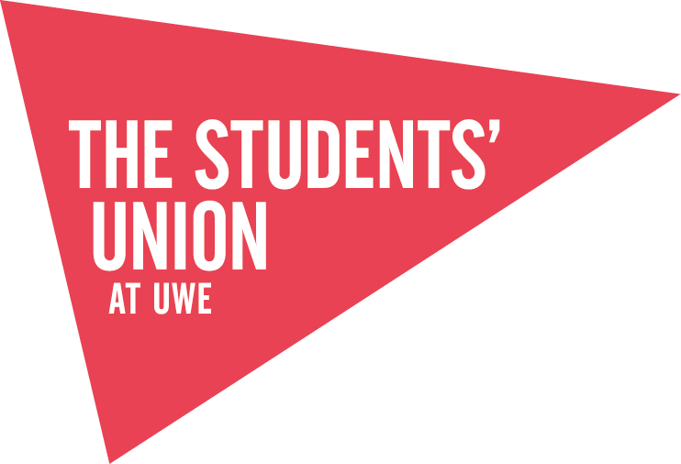
Society Development Review
Name of Society:

Please take time prior to your Development Meeting to consider some of the key areas in relation to your Society.
From the point of election, the newly elected committee members should shadow the outgoing committee where their position is handed over and they are introduced to the Opportunities Team and the systems in place. The incoming committee officially takes office at the start of the 3rd Term i.e. 4th April 2016

Achievements
What have you achieved this year and how will you continue this?
Training
What training do you and your members want to complete? Midas? Frist Aid?
Activities
What are you planning on doing that would benefit the whole society?
Improvements
How are you going to make the society even better?
Your Year in Review

£££ Membership fees £££
Standard?
Premium?
Semester?
Alumni/staff?

