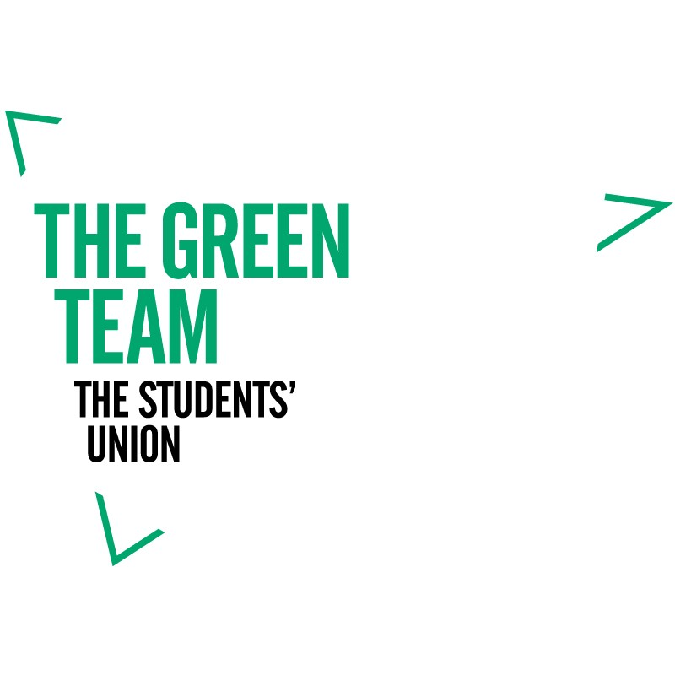

Before completing this form please see the
Change for Change funding criteria guidance

thegreenteam@uwe.ac.uk
The Green Team
@TheGreen_Team

Change for change

* If you are submitting on behalf of a Group or Society then please provide one key contact

Name*: Student Number: Email address:

Department/Course:
Project name:

Does your project relate to:
Saving energy Reduce, reuse, recycle Ethical procurement
(Type ‘x’ in box)
Sustainable food consumption
ESD (education for sustainable development) Sustainable travel
Green spaces/ biodiversity Other

What is the one main goal of your project? (Please provide a brief statement of what your project hopes to achieve):

What are your three Project objectives? (These are the smaller steps to achieve your main goal) Objective 1 Objective 2 Objective 3

Change for change
Description of your project (please provide more detail on the logistics of your project):

Do you know of any existing similar initiatives? (Could you share best practice or collaborate with them?):

What impact do you anticipate your project will have? (How will your project affect the University/
Bristol community)

How will you measure the impact of your project?

Change for change
How does your project demonstrate a commitment to sustainability?

What resources do you require? (We can try and provide you with training and skills needed to help you run your project). Please specify what you may need:

Will you need support from staff members? Eg. facilities team for events happening on university
property. Please specify:

What are the risks associated with your project? (What could potentially go wrong?)

Change for change
Total cost of project (Please provide a rough date and breakdown of costs where applicable):
Item | Date required | Cost in £

Please give an approximate timescale and action plan for the delivery of your project. Always bear in mind your other commitments, be realistically ambitious and keep in mind student timetabling – reading weeks, holidays etc.:
Date | Activity | Location

After completing this application form, please save the file in your own documents and send a copy over to our Green Team email address noted below. If you need any support completing this form, do not hesitate to get in contact.

www.thestudentsunion.co.uk/greenteam thegreenteam@uwe.ac.uk
The Green Team
@thegreen_team
#ThinkGreenBeGreat

