EVENT EQUIPMENT LISTINGS
PURPOSE
To provide a listing of all the current events equipment available to event organisers, holding events within Student Union premises.
This includes details such as:
- The area the equipment can be used
- Damage and/or replace costs
- Hire or Staffing cost

EVENTS EQUIPMENT
Image | Equipment | Quantity held by SU | Costing | Location
 | Black Foldable Event Chairs | 100 | Replacement/Damage Cost For Chairs = £20.00 (Per Chair)  Replacement/Damage Cost For Trolley = £150.00 | All Areas of the  Students Union
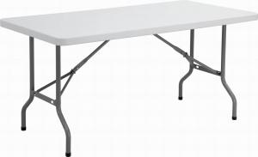 | Foldable Event Tables  Length 6ft  Width 2ft | 15 | Replacement/Damage Cost For Table = £105.00 (Per Table)  Replacement/Damage Cost For Trolley = £250.00 | All Areas of the  Students Union
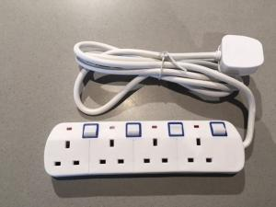 | Switched Extension Lead with Neon  Indicator | 5 | Replacement/Damage Cost Per Extension Lead = £20.00 | All Areas of the  Students Union
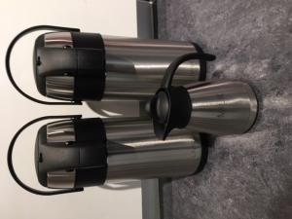 | Urns | 2 x 3L Flask Urn | Replacement/Damage Cost For Urn = £25.00 (Per Urrn) | All Areas of the  Students Union  & External
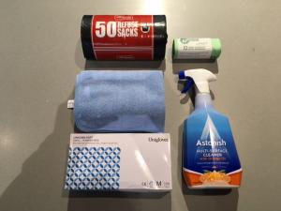 | Event Cleaning Kit & Hoover | 1 | No return cost for cleaning kit = £25.00  No return of hoover = £100.00 | All Areas of the  Students Union
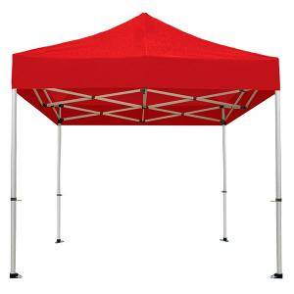 | Gazebo- Red | 3 | If returned damaged the bookee/user of this gazebo will be liable for a replacement cost of £250.00 per gazebo | Collection From SU Reception - Union 1 , Frenchay
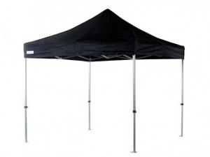 | Gazebo - Black | 3 | If returned damaged the bookee/user of this gazebo will be liable for a replacement cost of £250.00 per gazebo | Collection From SU Reception - Union 1 , Frenchay

