CREATING A MANNUAL PARTICIPANT LIST ON OUR WEBSITE
Step 1: log onto thestudentsunion.co.uk (you should have admin access for your club/society)
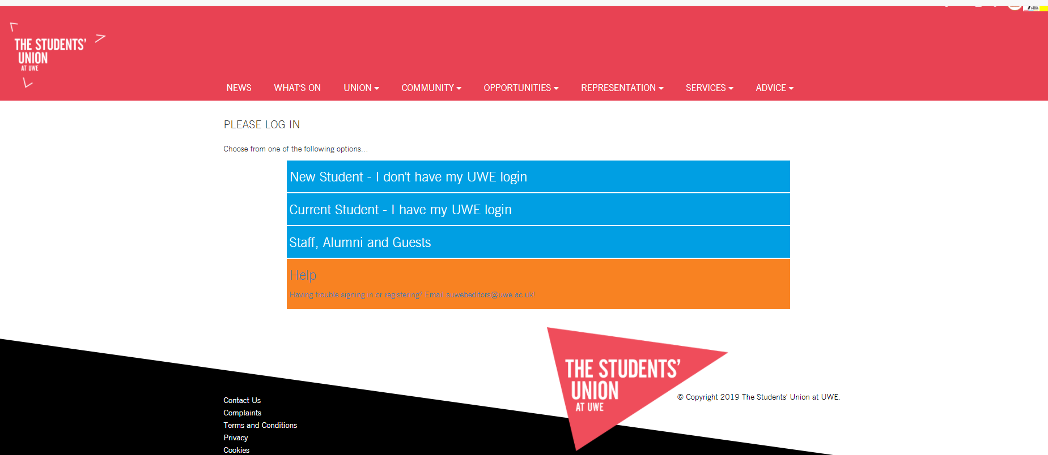

Step 2: from the “Opportunities” tab select “Sports” or “Societies” and select your club


Step 3: once on your club page click the grey cog in the top right corner and under the control panel section click “(club name) admin tools”
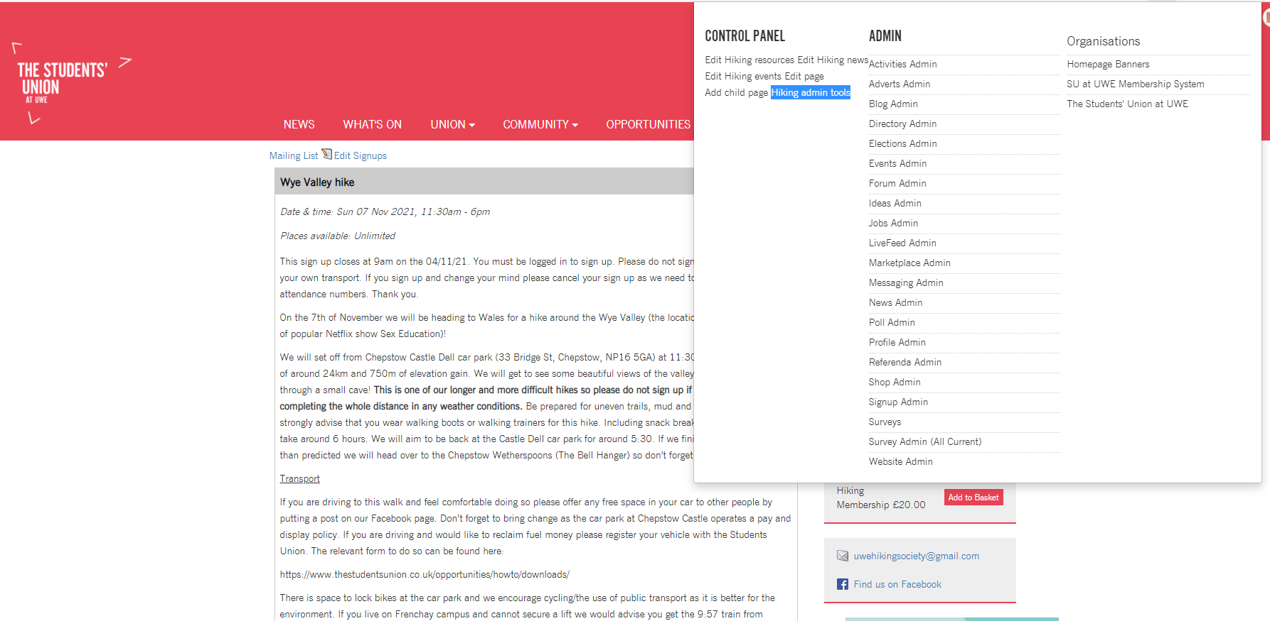

Step 4: select “Groups”

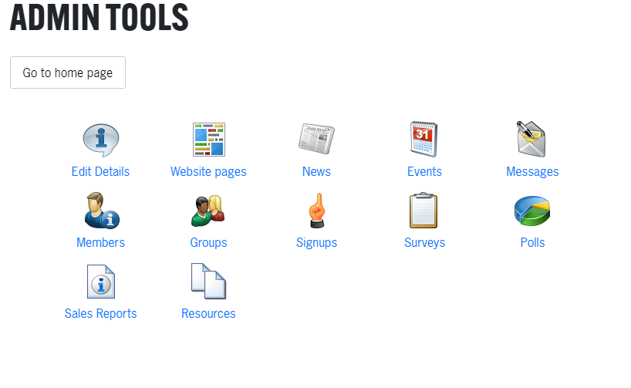

Step 5: click create new group, type in the date and “TRIP” into the name box and make sure to write the trip name in the following format: YEAR-MONTH-DAY e.g. 2021-11-07 Then select the type as “trip”
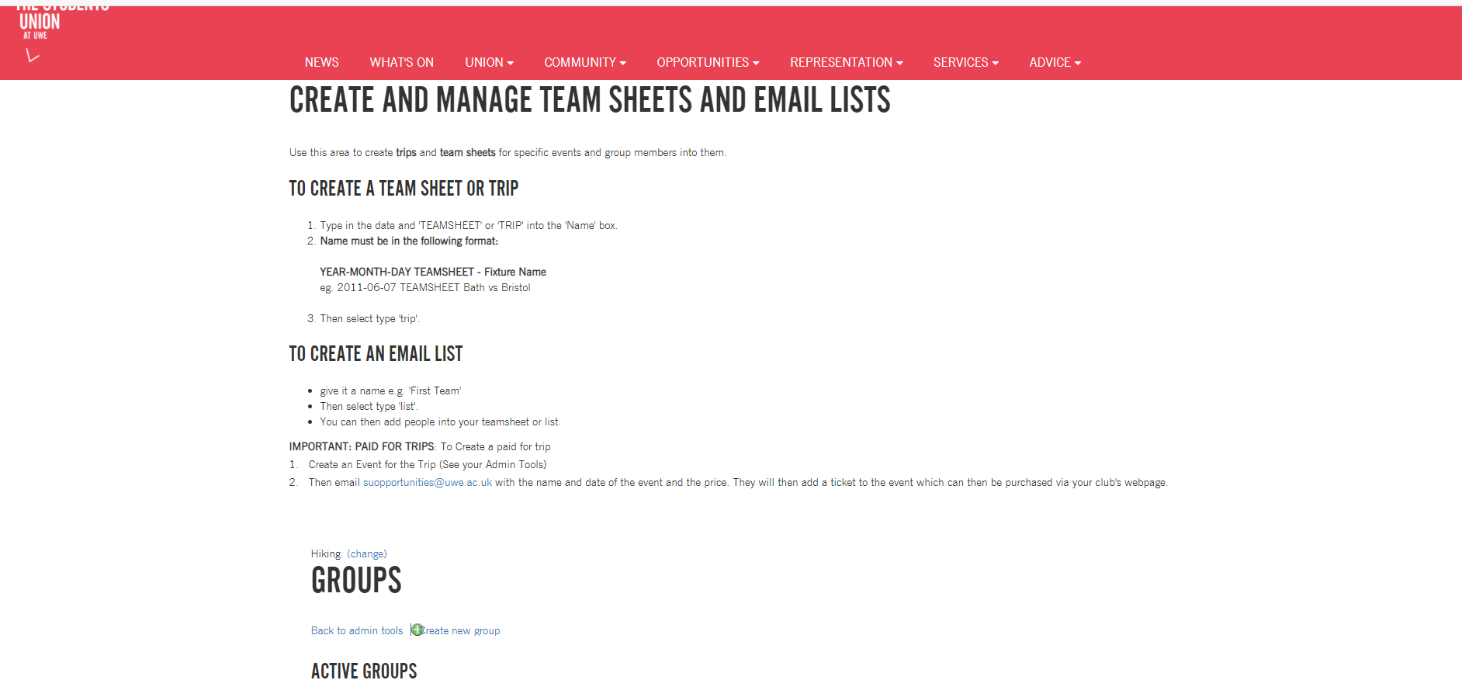

Step 6: select the group you have made from the list below
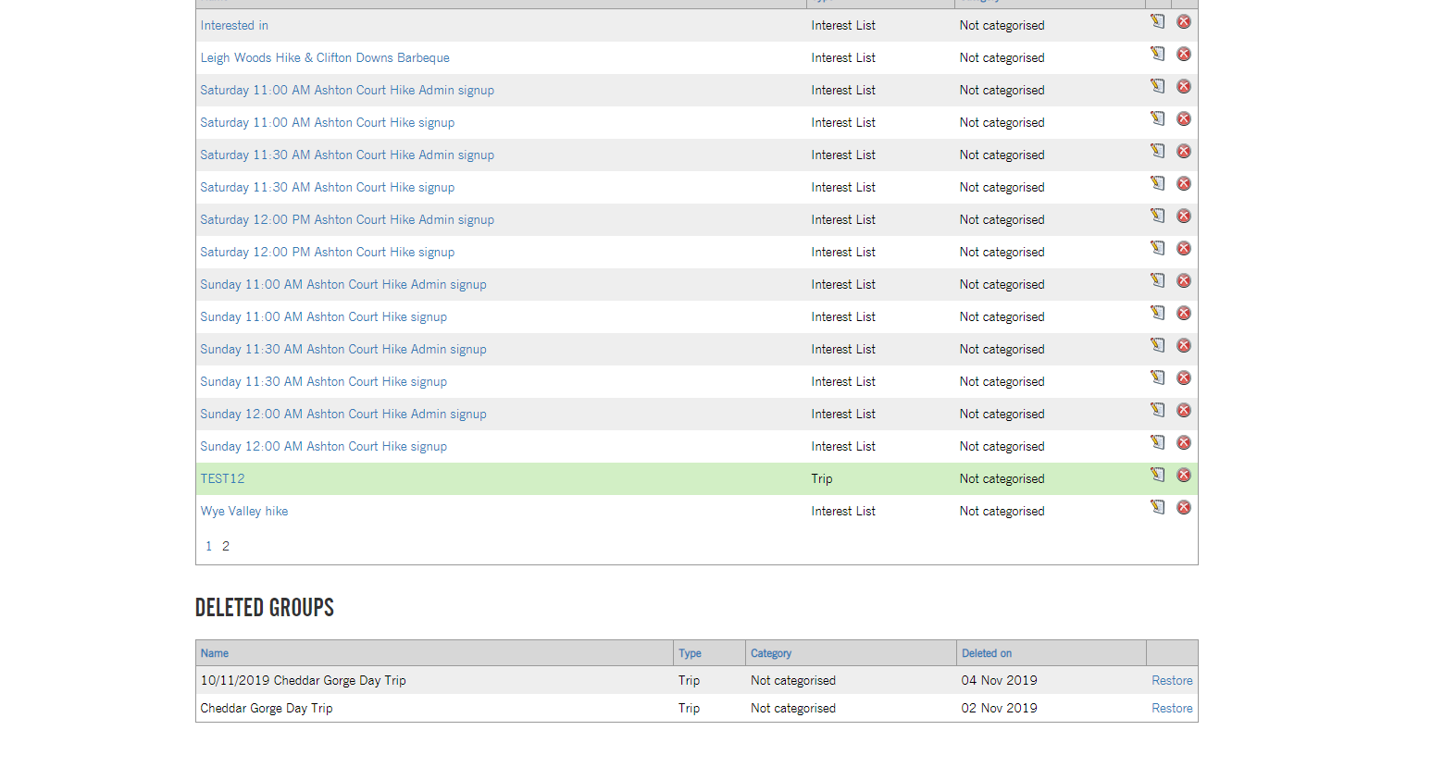

Step 7: select members then add them to list

