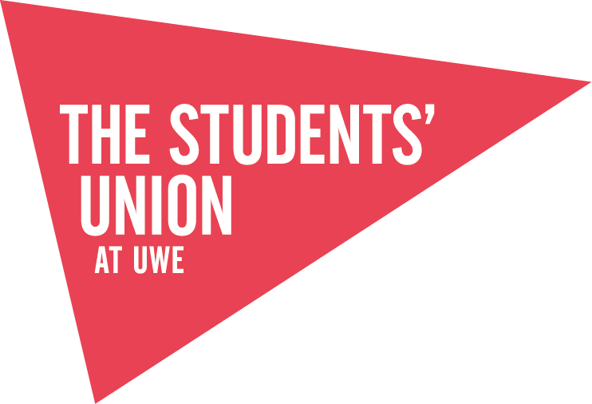
THE STUDENTS’ UNION AT UWE
PARTICIPATION AGREEMENT

The Students’ Union at UWE is committed to providing a forum that facilitates Freedom of Speech while providing a safe space for our students and the public. We support events that contribute to extra-curricular development of students while requesting that all speakers and attendees are respectful of the beliefs and opinions of others as well as the laws that protect individuals and groups from intimidation, discrimination and harassment. By attending a The Students’ Union at UWE event you are agreeing to uphold UWE and The Students’ Union at UWE policies and procedures regarding Freedom of Speech. Any breech of UWE/The Students’ Union at UWE policies and procedures may result in disciplinary or further action being taken.

