EVENT EQUIPMENT LISTINGS
PURPOSE
To provide a listing of all the current events equipment available to event organisers, holding events within Student Union premises.
This includes details such as:
- The area the equipment can be used
- Damage and/or replace costs
- Hire or Staffing cost
- Timeframe required before booking

EVENTS EQUIPMENT
Image | Equipment | Quantity held by SU | Costing | Location
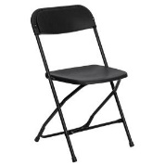 | Black Foldable Event Chairs | 100 | Replacement/Damage Cost For Chairs = £15.00 (Per Chair)  Replacement/Damage Cost For Trolley = £150.00 | All Areas of the  Students Union
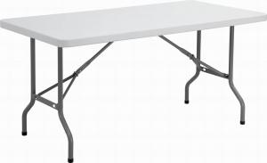 | Foldable Event Tables  Length 6ft  Width 2ft | 15 | Replacement/Damage Cost For Table = £75.00 (Per Table)  Replacement/Damage Cost For Trolley = £250.00 | All Areas of the  Students Union
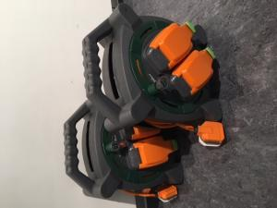 | Outdoor Power Reels | 2 | Replace/Damage cost = £25.00 per reel | All Areas of the  Students Union
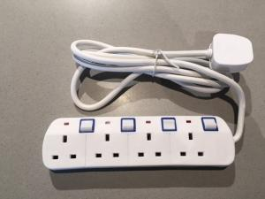 | Switched Extension Lead with Neon  Indicator | 5 | Replacement/Damage Cost Per Extension Lead = £10.00 | All Areas of the  Students Union
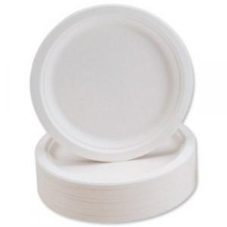 | Biodegradable Plates  [9 inch wide] | Aim to stock 200 at all times | £5.50 per 50 plates | All Areas of the  Students Union
 | Biopac Cups [200ml] | Aim to stock 200 at all times | £6.00 per 100 cups | All Areas of the  Students Union
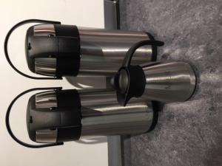 | Urns & Milk Jug | 2 x 3L Flask Urn  1 x 0.5L Milk Jug | Replacement/Damage Cost For Urn = £25.00 (Per Urrn)  Replacement/Damage Cost For Trolley = £10.00 (Per Jug) | All Areas of the  Students Union
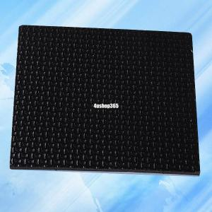 | Event Black Table Protector/Heat | 1 | No return cost for cleaning kit = £15.00 | All Areas of the  Students Union
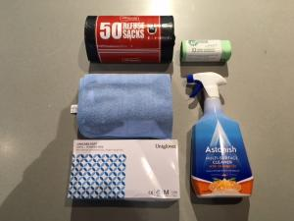 | Event Cleaning Kit & Hoover | 1 | No return cost for cleaning kit = £25.00  No return of hoover = £100.00 | All Areas of the  Students Union
 | Fully Compostable Cutlery | Aim to stock 200 at all times | £3.25 per 50 items  Please inform of what type, knives, forks or spoons), or if you are a club/society we can transfer from your budget. | All Areas of the  Students Union
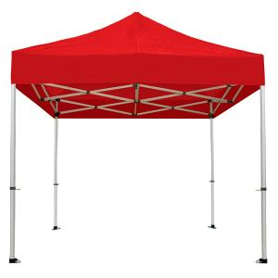 | Gazebo- Red | 4 | If returned damaged the bookee/user of this gazebo will be liable for a replacement cost of £165.00 per gazebo | Collection From SU Reception - Union 1 , Frenchay
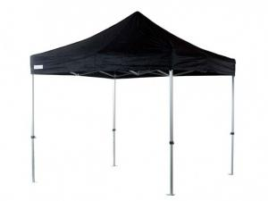 | Gazebo - Black | 1 | If returned damaged the bookee/user of this gazebo will be liable for a replacement cost of £165.00 per gazebo | Collection From SU Reception - Union 1 , Frenchay

