Top tips
Thank you for signing up to be part of our sustainable period trial – to help you out with your new product we’ve put together a top tips list for each product using feedback from last years trial and our own research. It can be nerve-racking trying a new product and whilst most people experience no problems when using sustainable products give yourself time to get used to yours and what works best for you!
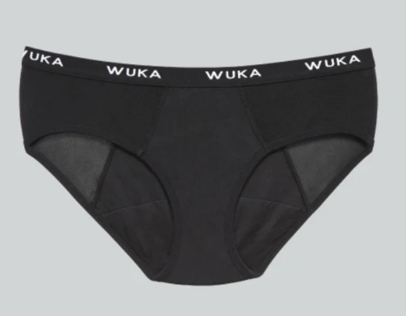
Period pants
Everyone’s cycle is different, so there is not an exact amount of time period pants should be worn however when you are wearing your pants, they should feel dry as the absorbent core works its magic. You’ll know when it is time to change your period pants if you notice a wet, heavy, or full feeling. It’s important to remember that your flow is unique to you, for some people they only use their period pants on their slightly lighter days and for others they use period pants throughout.
If you have a heavy flow and feel at all nervous or worried about leakage you can always try your new pants out on a day when you are going to be at home so you can see how they handle your flow.
Washing and care: Wuka advises that you rinse your period pants with cold water after using until the water runs clear. It’s best to do this immediately after removing. Avoid soaking them in water for too long as this can cause the material and bonding to wear and damage quicker as well as potentially causing mildew and musty smells.
After rinsing you can either hand wash or machine wash your pants. It is advised for both options that you use a cold wash and do not use fabric conditioner. Washing as cold as possible will prolong the lifespan of your pants and helps keep the absorbency as high as possible.
For the Heavy Flow and Super Heavy Flow pants it’s advised to wash the pants inside out and if machine washed giving them an extra spin.
You can either air dry your pants outside or indoors on an airer (or equivalent) and for the heavier flow pants you can pop them on a warm radiator to help dry. Do not tumble dry them!
Feedback last year highlighted that to avoid odours it is important to wash your pants straight away. If you don’t have time to wash them fully its beneficial to give them a thorough rinse at least!
Extra tip: You can soak your pants in a solution of diluted white wine vinegar and water for 20 minutes to help keep them fresh and free from odours.

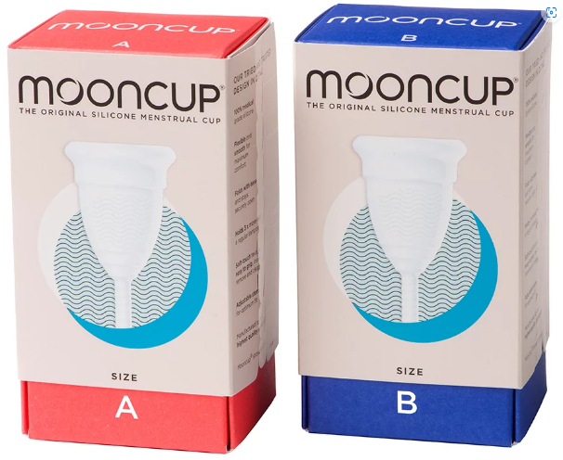
Menstrual cups
Some people find menstrual cups easy to use and insert and for others they can take some time getting used to/finding what works best for you. Some leakage is perfectly normal and even expected when you’re first using one! You may feel more comfortable using your new product for the first time on a day where you’ll mostly be at home or have plenty of time to insert it.
Inserting your moon cup:
Always wash your hands before handling, inserting, or removing your menstrual cup to help prevent yeast or other vaginal infections.
There are multiple ways to fold your cup in order to insert it – you can find folding techniques and pictures on Mooncup’s website (mooncup.co.uk) or there are plenty of video tutorials online as well. Remember different techniques work for different people so find the one that suits you best!
Mooncup also have a step by step guide on how to insert your cup which again can be found on their website under the ‘HOW TO USE’ tab.
Washing: Before you use your Mooncup menstrual cup for the first time and after you’ve finished your period, we recommend giving it a thorough clean. To do this you can either:
boil it immersed in water for 5 to 7 minutes (in a pan you use just for this purpose) If you don’t feel comfortable doing this i.e in a shared kitched you can instead:
use sterilising solution or tablets. These are commonly used to sterilise baby equipment. Follow the manufacturer’s guidelines for dilution and soak for the minimum recommended time. Then rinse thoroughly with clean water.
Use a specialised sterilising cup: these can be found online. They are silicone containers that can be put in the microwave with a bit of water and your cup.
Using your moon-cup in public bathrooms: Feedback last year showed that some participants were unsure/uncomfortable with taking out, cleaning and re-inserting their moon cup in public bathrooms. If you need to clean and re-insert you can follow these steps:
1.Wash your hands before entering the stall.
2. Remove and tip out menstrual fluid into the toilet.
3. You can either use toilet paper to wipe clean your cup or bring a water bottle with you and rinse it above the toilet bowl. (You can give it a more thorough clean later on)
4. Re-insert and wash hands.
Reminder: (Take as long as you need to do this whether in public or at home! Having a spare tampon or pad with you when you’re first using your new product means that if you come into any mishaps then you’ve got back up with you!)

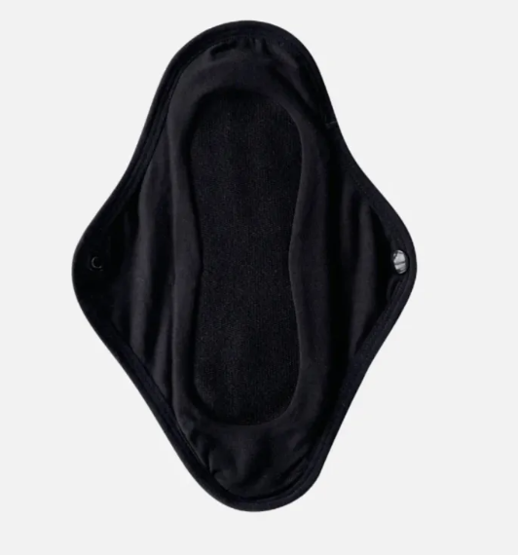
Re-usable pads
Reusable sanitary towels are much the same as their disposable counterpart. You wear them in your pants, and they work by locking blood away in an absorbent core. The main difference is that reusable pads are made using materials such as cotton or bamboo, and are designed to be washed and used again, rather than disposed of after just one wear. (Wendy Graham, 2022)
Much like period pants there is no set time you should wear your reusable pad for – it is dependent on your cycle and flow type just like disposable pads. You will know when it’s time to change your pad when you notice a wet, heavy, or full feeling.
If you like your experience with the re-usable pad you may consider buying a few more so that you have enough to cover your whole cycle. Sustainable products can be expensive so it’s worth building up your collection gradually.
How to use
Reusable pads are worn the same as disposable pads. Re-usable pads have buttons on to secure the pad instead of sticky tabs. When you want to remove your pad simply undo the buttons and take off.
Washing and care:
Machine wash -
After using, rinse your pad with cold water and then:
- Place it in the washing machine with the rest of your laundry.
- Or after rinsing store it in a wet bag until you put your next wash on.
- Wash on a regular cycle at 30 degrees or lower. Avoid fabric conditioner and tumble dryers as these can affect the lifespan and performance of your pad.
Hand wash –
- Add warm water to a clean sink or bucket/bowl.
- Wash the pad/s with a little bit of laundry detergent or soap
- Rinse, wring out and hang up to dry.
We advise not soaking your pads for long periods of time as this can develop a bad smell which can be hard to get out or grow mould on them. A rinse with cold water before washing is enough.
Reusable Sanitary Pads: A Beginners Guide To Getting Started - Moral Fibres

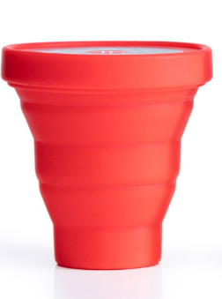
Menstrual cup sterilising pot
The silicone period cup steriliser is collapsible, making it easy and discreet to take out and about. To use, simply place your period cup in the sterilising pot with a splash of water and pop in the microwave for 3 minutes.
Once its been microwaved you then take your cup out, pour the water away and you’re done. Your cup is now ready to be used for your next cycle.

