HOW TO?
RUN A
STUDENT CAMPAIGN

INTRODUCTION
The purpose of this booklet is to act as a guide for students wanting to run a campaign.

What is a campaign?
A campaign is the coherent series of activities that work to achieve a specific goal.
The purpose of campaigning is to create change.

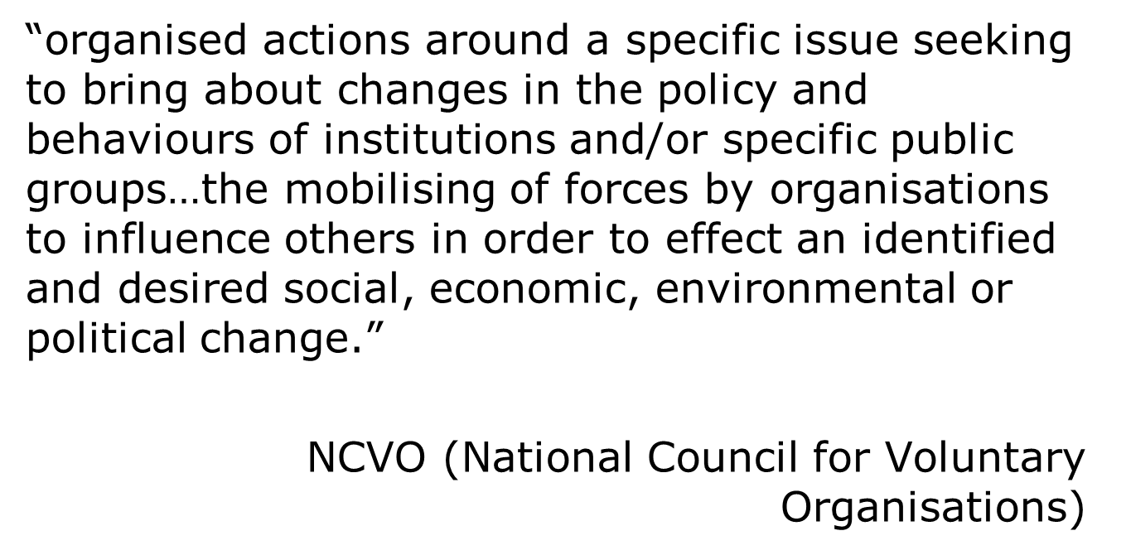
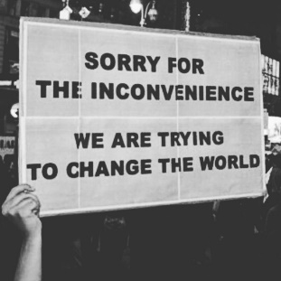
“Harnessing a collective will and effort as an engine of change for public benefit.”

Back to the Future thinking: project yourself forward to the end of the campaign, if everything happened perfectly, what will it look like?

IDEA

So you have a great idea for a campaign? Great! Ask yourself the following questions:

Step One: The goal: what you want to accomplish by running the campaign?
What is your desired outcome?

Do I really need to campaign? Can I get what I want by other means e.g. can it be delivered through asking or lobbying?

Ask yourself: ‘why hasn’t this happened already?’ You can map the forces for and against or create a ‘problem tree’.
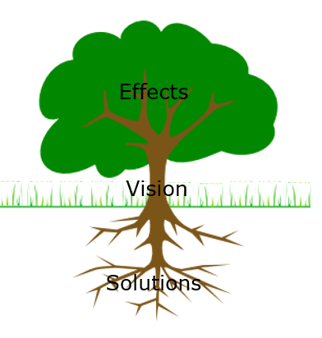
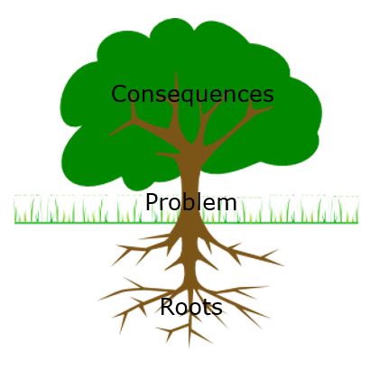

Problem Tree Solution Tree

WHAT’S THE GOAL
Step number one is for you to decide exactly what you want to achieve by running the campaign.
Clarity is the most important single quality of goal-setting within running a campaign and perhaps the most important single quality of success. Instead of fuzzy goals like more engagement.....be specific about exactly how much you want to achieve and in a specific period of time.
We can be unconsciously preoccupied with the fear of failure. Why? Well, if you don’t set clear, specific goals, then you can’t fail to achieve them. So your subconscious mind is actually protecting you by helping you to avoid failure.
You must resist and overcome this tendency by having the courage to be bold and specific about exactly what you want your campaign to look like and achieve.
- Where did this idea come from?
- What do you want to change? What is the issue you are tackling?
- What problem in the community will it help solve?
- Is your project necessary? How have you checked?
- Might someone else be doing something similar? You don’t want to duplicate work.
- Are there other ways I might solve this problem?
- What does success look like? What’s the Impact?

Write down the problem you want to tackle, flip statement into a positive aim.
SETTING AIMS
Clearly state what you’re trying to achieve, and how you’re going to do it.
This is also known as setting aims and objectives.
Your aims are what you are trying to achieve, the changes you are trying to make. Aims therefore tend to start with words that indicate a change – to increase, to reduce, to improve, etc.
What to consider to achieve your aim:
- Are there other ways I might solve this problem?
- Who do you want/need to influence?
- Who is your target audience? Define this audience
- What communication channels can I use to engage with this audience?
- What actions are appropriate to bring about this change?
- What is your key message?
- What communication channels can I use?
- Who might support the idea?
- Who might oppose it?
- Who are my stakeholders?
ORDER
Right Components – Right Order
You need to follow the sequence:
> awareness > alignment > engagement > action

The campaign involves a deliberate series of revelations or communication exercises to take the 'audience' from a state of ‘ignorance’, through interest and then concern (components of awareness), into anger and engagement (motivation), and finally into a state of satisfaction or reward. If that happens, the campaign participants or supporters will be ready for more. Communicate them all at once and there's no involvement in the 'story' of the campaign. A good campaign has to be like a book or a drama - the outcome must be important but unknown.

Showing a problem may lead to concern but in itself that won't lead to action. Show them now is the opportunity to force a change, to implement the solution, and give them a way to act - and you have the conditions for engagement.
Start from where your audience is!

TACTICS
- Memorable messages, stories
- Ensure your messages are inclusive and use inclusive language. Avoid using cultural reference that only certain groups will understand.
- Know your target audience – make it relevant and meaningful and be unique
- How to engage with students?
- Make it understood
Do people know about the behaviour? Do they believe it’s relevant to them? This lever raises awareness and encourages acceptance.
- Make it easy
Do people know what to do and feel confident doing it? Can they see it fitting into their lives? This lever establishes convenience and confidence.
- Make it desirable
Will doing this new behaviour fit with their actual or aspirational self-image? Does it fit with how they relate to others or want to? Social norms are very powerful to create behaviour change.
- Make it rewarding
Do people know when they’re doing the behaviour ‘right’? Do they get some sort of reward for doing it? This lever demonstrates the proof and payoff.
- Make it a habit
Once people have made a change, what can we do to help them keep doing it? This lever is about reinforcing and reminding. Are you offering a one-time reward that students might lose interest in, or are their continuous rewards you can promote to ensure sustainable behaviour change?

K.I.S.
Keep It Simple.
Campaigns are needed because there is a problem which has to be made public in order to be resolved. Effective motivation needs simplicity in message and purpose.
Communicate only one thing at a time. Use a simple unambiguous 'call to action' which requires no explanation.
Keep it simple
• One message.
• Urgent problem that must be made public to resolve.
• Motivate by keeping it simple.
• A ‘call to action’ that needs no explanation.
• The issue is complex, but your campaign must not be.
• Communicate the problem, the solution, the opportunity.

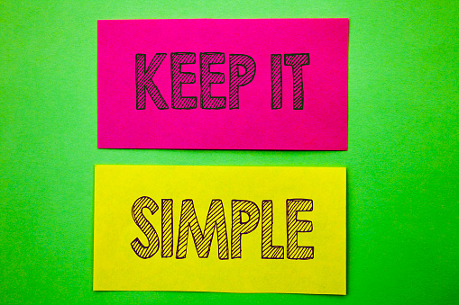

THE TO-DOs
Make a list of everything you could possibly think of that you will have to do to achieve the goal of the campaign.
Make a plan and a timeline.
Allocate responsibilities and actions to different people in the working group and ensure they have enough time to dedicate to these tasks. We recommend involving department managers to help you understand the next steps to make your event/campaign a reality.
The Community Events checklist and guides help you understand the steps to organise an event: file:///S:\SU\General\Membership%20Services\Community%20Team\Policies%20and%20Proceedures\Health%20and%20Safety\Events\Community%20Events%20Questions%20and%20Checklist.docx
Take your list and organise it into a plan. A plan is really quite simple.
It is a list organized by priority and importance.
- What steps will you take to review your progress?
- With whom are you going to review your progress & when?

MAKE REAL THINGS HAPPEN
Events drive awareness and engagement.
• News is about things that happen. Not ideas or concepts.
• What is the verb? Starting, publishing, blocking, rescuing, occupying, marching, lobbying.
Communicate in pictures
• Events generate pictures.
• Invite a photographer, ask them to tell the story.
• If you can take a photo of it, you’re going to enable others to feel part of and connected to your campaign.
Pictures are far more powerful than words. Good ones tell the story and the best need no caption.

COVID-19 WORLD
This page is less relevant is 2023/24 – but it is good to keep in mind.
In a Covid-19 world, we have to reconsider how we engage students in and deliver campaigns. In-person events might not feasible or the best approach.
In addition, as more virtual activity takes place, your campaign message needs to be clear and simple to be effective.
As the academic year is changing, and resources are scarcer, we have to be more streamlined with our campaigning. It is about quality, not quantity. We will focus on doing less to achieve a more powerful outcome and utilise our limited resources effectively.
Recommended read: Rethinking Online Events.
We will focus on THREE key areas for each campaign, thee will deliver the message and seek to achieve the deliverables agreed.
For example:
- Marketing and awareness campaign (digital content, blogs, video and social media throughout, book giveaway)
- One online event, student engagement and conversation, quiz, panel discussion
- An action to take, e.g. signing a petition, writing to MP
Campaigns do not have to be limited to their ‘month”, so all good ideas can still be utilised elsewhere. Intersectionality is essential to each campaign: https://www.nusconnect.org.uk/resources/intersectionality-101.
EVALUATE
Monitoring and evaluating your campaign as it progresses will enable you to:
- see if you are on track
- demonstrate your effectiveness or successes
- be held accountable.

Ask yourself:
- How will you know you have achieved your
- objective?
- How will you present your outcome?
- How will you measure the impact?
Please utilise this fantastic resource from NCVO (Championing Voluntary Action):
https://knowhow.ncvo.org.uk/campaigns/campaigning-and-influencing/developing-your-campaign-strategy/evaluating-the-impact-of-your-campaign
Some example of evaluation methods include: surveys, focus groups, pledges, social media engagement, ball-o-meter, comment tree.

