Halley Frenchay is registered with Ofsted. It operates from a modern, spacious, purpose built building that is situated next to the main entrance of the university. The area for the children consists of three main rooms: our “Bluebell” room that caters for 18 children aged from 3 months to 2 years, our “Lavender” room that caters for 20 children aged two years to three and a half years and our “Apple tree” room that caters for 24 children aged from three and a half to five years. Bluebell room benefits from having a separate sleep area with cots, where the babies and toddlers can relax and have quiet time and a milk kitchen and nappy changing area. All rooms are adjoined to encourage interaction between the different groups. The rooms have french doors leading out to the outdoor area. Our outdoor area is large and fenced from the public. It consists of a level area, a “hilly adventure” area and an extensive “woodland” garden. The natural environment and woodland area has been maintained and the area benefits from a variety of outdoor equipment that assist and promote all aspects of children’s physical development.

Our Policies and procedures

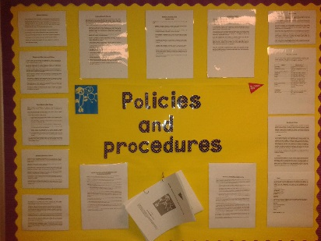

The nursery operates within the framework set by the National standards and our Policies and Procedures. If you wish to obtain a copy of our Policies and Procedures handbook, please speak to the Manager.

Fees
Student/Staff

Age Group | Daily Rate | Morning Rate | Afternoon rate | Weekly Fees
0-2 Years
2-3 Years
3-5 Years

Fees

Community
Age Group | Daily Rate | Morning Rate | Afternoon rate | Weekly Fees
0-2 Years | £85.63 | £49.75 | £45.41 | £405.70
2-3 Years | £80.25 | £46.69 | £42.45 | £380.92
3-5 Years | £76.38 | £44.58 | £40.28 | £362.91
Terms and Conditions

Fees are inclusive of meals and snacks. Fees are payable at the beginning of the month and are calculated on a weekly basis. Reductions will be given for bank holidays and days the university remains closed. A deposit of £250.00 will need to be paid at the time of registration to secure a place. Emergency and non- scheduled attendances are available only if room ratios can accommodate and will be charged at the applicable standard room rate - no NEG will be applied in these instances.

Please see separate information regarding the Offer of Free Hours at Halley Nursery


UWE Term Dates for Academic Year 2024/2025

16th September 24- 20th December 2024
6th January 2025-4th April 2025
28th April 2025- 6th June 2025

Nursery Hours

8.00 a.m. –17.30 p.m

Morning Session: 8.00 a.m. – 12.30 p.m.
Afternoon Session: 13:00 p.m. –17.30 p.m.

We are open 50 weeks of the year but we offer UWE term time for students and employees, who wish to utilise them. We are closed on bank holidays and on days that the university remains closed.

If you wish to look around our nursery ,please contact us on 0117 3286290

