

SU001- Negative Environmental Impacts 2023-2024

Criteria
The union has identified its most significant negative [environmental impacts] and published them.

All students' unions have issues where they could make improvements to reduce their negative sustainability impacts and increase their positive impact, such as energy use, procurement, waste production etc.  Identifying specific impacts, and ranking them in terms of the relative size of the negative impact, can help organisations prioritise their sustainability actions.  If using an existing list of impacts from previous year's participation in Green Impact, the list should have been reviewed this year. | Auditors will be looking for a well-documented assessment of at least the top five environmental impacts of the union. The list should be ranked by magnitude of the negative impact. There is no right or wrong way to do this, but plenty of guidance is available online. There will be variation between unions depending on what operations they have: commercial unions may have different impacts to non-commercial; multi-site unions may have different impacts to single site unions, etc.  Evidence will revolve around the list of impacts. The list should be dated and in the public domain, and ideally on the union's sustainability webpage. Ideally the impacts will be quantified (the amount of miles, the size of carbon emissions, the weight of waste to landfill etc.) and there will be reference to what the union is doing to reduce them.

The Students’ Union has been reporting on our negative environmental impact for the last 6 years:
- Please find attached our negative impact report, also available to view through our Sustainability WebPage: https://www.thestudentsunion.co.uk/sustainability/sustainabilityactionplans/
- The report details a range of environmental impact and lists them in rank order, according to CO2e. We have chosen the impacts due to the monitoring and reporting systems The Students’ Union and UWE Bristol have in place.
- We detail the efforts taken presently to reduce these negative impacts and the plans moving forward.
- The University and The Student Union at UWE took the decision during 2018 to work towards inclusion of the student union into the scope of the university’s ISO14001 management system. Despite the two organisations being separate legal entities, they already collaborate on environment and sustainability at a variety of levels from provision of related building services and facilities through to sustainability governance and awareness campaigns. A review of SU-related environmental aspects and impacts took place during November 2018. This review is a requirement of the ISO14001 standard and will enable the university and the SU to better understand key environmental and sustainability risks and opportunities.
- Moving towards UWE’s 2030 target of a net carbon neutral campus, we will be understanding our impacts in all three scopes of mapping our carbon footprint.
- In 2023-2024 The Students Union at UWE have been exploring methods and ways to improve data collection of our negative impact. This work is ongoing as it requires in some instances our systems to changes.
- This year the Students Union have been working with UWE Estate Carbon and Supply Chain (Scope 3) Officer Tom Finn who has been advising and support regarding mapping, coding our procurement with further estimation on the carbon associated with in. This work is still in progress and explored to be applied to the organisation, particularly our commercial services who have a high procurement rate.
- In addition to this we have explored what it would require measuring our travel more accurately for both our student and staff activities.
For students we have looked to amend and develop our fuel/milage claim form so that we request the type of vehicle which would lead us to be able to apply a more accurate conversion rate. https://www.gov.uk/government/publications/greenhouse-gas-reporting-conversion-factors-2023
- For our staff travel we have looked at our current expenses system where fuel and milage claims are tracked can be edited to include the type of vehicle. Our Finance Manager has informed us that our current system (Staff Savvy) will not support this functionality. In the future when tendering a new financial HR system, we will look ensure this function is available.

Below is the methodology of the scoring: [extracted from our procedure’s manual]
Significance Scoring Methodology

The scoring criteria for assessing the significance of each aspect is outlined below:
 | 1 | 2 | 3 | 4
Direct or indirect control | Indirect / Influence | Direct control
Frequency of activity | Negligible usage/infrequent operation | Low usage/Normal operation | Moderate usage/Abnormal usage | High usage/ emergency conditions
Environmental effect | Insignificant | Minor | Moderate | Major
Stakeholder Interest | Limited | Moderate | High
Existing controls | Full control/no requirement for control | Moderate control | Limited control | No controls
Compliance Obligations | No relevant obligations | Compliant with obligations

The Students’ Union have started this work from scratch again with UWE Bristol, in light of our 2030 commitments to reach net carbon neutral across all 3 scopes.
We have been working proactively with UWE Sustainability and UWE Energy Teams to look at an approach. Working with UWE Bristol’s ISO 14001 Officer, we created new workshops for all Students’ Union departments, these ran in Autumn Term 2021 and the information reviewed Spring 2022.
We met with all department heads to scope al their departmental activities and the decision they make. We mapped what data was already being captured and if it wasn’t why not and how it could moving forward.
The Students’ Union attended a webinar on carbon management (please find notes attached) and are using this framework to support our approach.
6 steps - CARBON
- Check – working with all departments and UWE to map our scopes of activity. Check was data we collect.
We have worked with UWE to improve our data set across waste, energy and water, with new meters and better deep dives into certain areas.
- Assess – we are now assessing common themes across the departmental mapping to pull out key areas we know we have a big impact, to either better record and assess this, so we can reduce and monitor, or to enable us to estimate our carbon footprint overall more successfully. These projects will then feed into our new 4 years strategic plan action planning cycle.
- Record – we have worked with our Finance Manager to create a new negative environmental impact dashboard and database. We can more effectively update these figures and monitor our progress year on year. We can add in new data sets as we being them on board and enable better reporting. Please find attached our new database showing our top 5 negative environmental impacts.
- Brainstorm – Bringing together 2 and 3, looking at the best gaps to fill and make the most impact. Working with student leaders and departments to go this effectively.
- Ordering – create the plan!
- Numbers

As part of our Assessment Phase, we believe a piece of work on staff travel, purchasing and supply chains are key focus areas for future years. Our student survey tells us that a main driver for students is single-use plastic, so this will be the third priority area for audit, reduction plan and monitoring.

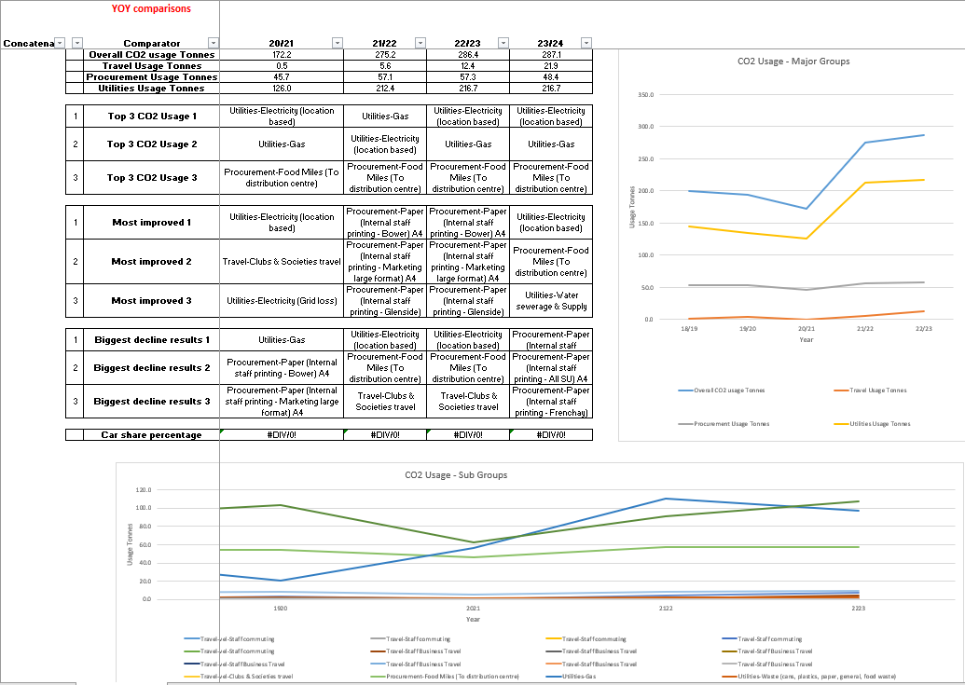
Appendix – Notes on negative environmental impact 2023-2024
Energy Data Information
- Improved meters across SU venues so can have accurate reports and localised reporting.
- Resolved an issue with meter reporting in The Students’ Union means recording is now more accurate, this means past data is not reliable for comparisons.
- Have a stable data set for the future to support 2030 net carbon neutral goals
- UWE Bristol working with a specialist company to commission every single meter to know it is accurate.
- Energy consumption has increased due to increase in building use, better metering and more accurate reporting, and means previous stats inaccurate and not able to account for it.
- Splitting data of commercial and non-commercial to see how controls in the Union 1 building on student activity is holding the data steady. We are going to explore with UWE’s Energy Team.
- Our Community Manager, Buildings Manager and Commercial Services Director have been working with UWE Carbon Action Manager to look further into the SU utilises usage. Thus far it has included:
  - SU Staff having access to live utilities data software;
  - Meetings held to look at the scope of the project and to get some clarity moving forward;
  - SU Buildings Manager completed user feedback in relation to use of the buildings focusing on utilities;
  - Onsite walk through to understand the functions of each area and details (such as opening times, high/low usage) and being able to visually see the space with UWE;
  - From this a U Block Energy Survey has been complete and will be explored further by UWE and The SU.
The total greenhouse gas emissions for the Students’ Union have increased this year by approximately 15 tonnes in comparison to the previous year. This is primarily due to an increase in electricity use at the main SU building – U block, which accounted for almost a 10 tonne increase in emissions.
The cause of this increase needs further investigation to be fully understood, but it is worth noting that water consumption has increased by a similar amount to electricity (5%). Water is a good indicator of building occupancy and this could suggest that the building was in greater use in 2023-24 and therefore a modest increase in electricity use would also be expected. Without further analysis however, this cannot be confirmed as the cause of the change in emissions this year.
Gas use has also increased in U Block, but more noticeably at Halley Nursery. These combined increases account for the almost 6 additional tonnes seen in the overall greenhouse gas emissions total. Both increases are potential causes for further investigation as weather data suggests that gas used should have been less over the last year in comparison to the previous year as temperatures were warmer.

Waste Data
The SU has 3 bin store locations, The Student Union, and Halley Nursery at Frenchay campus and The Student Union at Glenside campus.
We have a shared bin store at Frenchay, since November 2021, with 3 other departments (Bristol Robotics Labs. Heath Tech Hub, CFPR Centre for Fine Print Research).
As it is a shared bin store the following split has been applied: 50% for General Waste, Paper & Card and Plastics & Cans and 80% for Glass and Food Waste.
This will be reviewed next year once the new bin store for CFPR and Health Tech Hub has been completed.
Halfway through this year we have switched to a new waste contractor, Suez, whom are providing the exact data for every waste stream. The previous contractor, Veolia, provided mostly estimates. As a result of this, the data is not comparable to past data but going forward we will be able to identify trends and recognize where improvements can be made.
We are now operating under a new pay by weight model and bins must be 50% full to be tipped. There is a small lift fee each time a bin is emptied so this rule will ensure we aren’t paying for barely filled bins to be tipped.
There is currently 7 months of waste data under the new contractor. An average from these months has been used to get the totals for the first 5 months of the year to give the following statistics:
- 2023/24 saw a total of 41,009kg produced and a C02e of 0.75.
- The Student Union on Frenchay campus is the largest producer of waste, producing 26,272kg of waste with a recycling rate of 55%.
- The Student Union at Glenside campus only produces 7,478kg of waste but has a lower recycling rate of 31%.
This year’s figures show that the previous years recycling figures were overestimated, particularly plastics & cans and glass. The below table shows the drop in waste overall across thee 3 SU bin store locations but resulting in a decrease in recycling rate from 69% to 45%.
Total Weight (kg) | 22/23 | 23/24
General Waste | 24273 | 22457
Paper & Card | 10131 | 9783
Plastics & Cans | 5529 | 1846
Glass | 8056 | 2882
Food Waste | 6307.6 | 4042
Grand Total | 77690 | 41009

Printing Information
- 2023/24 we haven’t been able to gather the printing stats for all our printers this year as the software that was used to capture the information Blueprint, is no longer being used due to high yearly costs. ITS have migrated over to Uniprint which can only track printers with the swipe access feature.
- This year we’ve also added an ink & paper log for our large format printer to keep a track of how much ink & paper we’re using over the course of the year so that we can compare against years to come.
- The only access feature we have on our Canon printers is a report on the all-time stats. We’ve added this to our monthly process to keep track of our main office printers so we can keep track of the print numbers so by this time next year we will be able to provide a break down on A4/A3, black & white/Colour, 1 sided/2 sided prints.
- As for our smaller UWE owned office printers, I will see if there’s a possibility in getting the swipe access feature installed onto those printers, that way ITS will be able to record the printing stats using Uniprint.
- The number of physical printers remains the same as last year, we currently use 3 main all in one office printers, with 1 large format printer & 5 small form factor printers in the small offices across Frenchay & Glenside. We will look to reduce the number of small form factor printers next year to reduce our carbon footprint.

Digital Signage
- We recently completed an audit check to make sure all V-IT digital signage screens had auto turn on/off enabled. This is done as part of the installation process on all new screens to ensure we save energy. This is also adjusted to shorter auto on/off times during the Christmas & summer holidays. As for our Moxie digital signage PCs, the auto on/off is setup on the BIOS when the digital signage operating system is built. All digital signage operating system builds are built by UWE ITS.
- All digital signage screens across our three campuses are programmed to auto turn on at 7:59am & auto turn off at 23:00pm & the signage goes live at 8:00am every day of the week. This is to allow for the system to boot for a minute before the signage playlist goes live.
- The digital signage screens stay on for 15 hours a day & it consumes approximately 2.625 kWh of energy. If the screen were to stay on for 24 hours, it would consume approximately 4.2 kWh of energy. Having the screens on for 15 hours a day instead of 24, saves us 1.575 kWh of energy which is the equivalent of charging 126 iPhones.

Workstation Screens
- We recently completed an audit check on all of auto turn off compatible monitors across the organisation. New BENQ & HP monitors are configured to auto turn off after 10 minutes of inactivity. Older BENQ & HP monitors that don’t have the auto turn off feature have stickers on to remind staff to turn off the monitor once they’ve finished using them.
- All new BENQ & HP monitors are configured to auto turn off before they’re installed onto workstations across our three campuses.
- If our most common HP E24u G5 monitor stayed on for 24 hours, it would consume approximately 0.54 kWh of energy. Having the auto turn off feature enabled, the monitor would be used on an average of 8 hours per day, consuming approximately 0.18 kWh of energy. Saving 0.36 kWh of energy per day, which is the equivalent of charging 29 iPhones.

Marketing
- When entering a marketing request on our ticket system, each team is being reminded: ‘Before requesting printed material, please take into consideration the impact of the materials and decide if they are necessary for the campaign duration.’
  - Evidence:
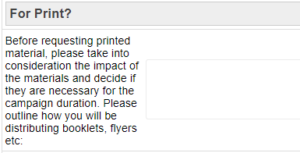
- Marketing team ensures teams are aware of the variety of existing marketing channels outside of printed posters for every campaign.
- As often as possible, we design assets with no specific date so they can be reused.
  - Example: Elections banners.
  - Example: Freshers’ Fair wayfinding. 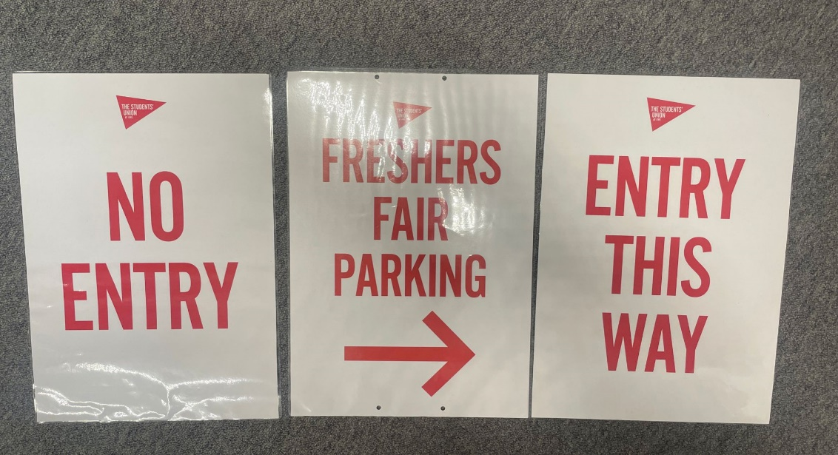
- We have been using off cuts from our large format printer for A3 and A4 printing.
  - During our Elections period we challenged a request for externally printed flyers, and instead printed postcards using our offcuts to help reduce waste. Evidence:
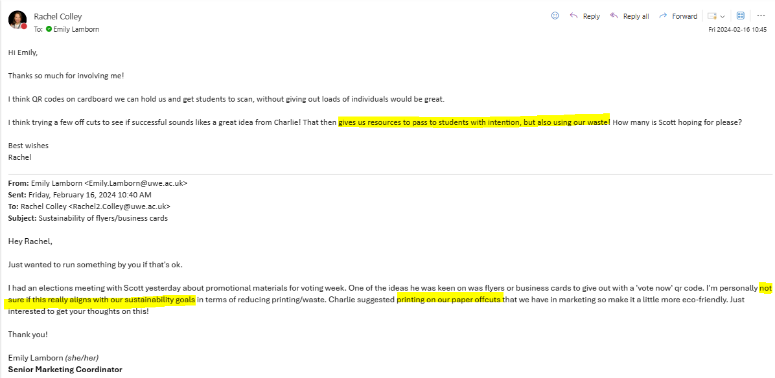
- The Media Pack we send to prospective commercials is entirely digital. This year we have created an online magazine which means that we reduce the amount of data we send to each commercial as we are not attaching a PDF to each email.
- We make sure our large poster frames across campus contain year-long campaign posters, in order to reduce having to print new posters on a regular basis. We also make sure our poster frames have locks ensuring the print work stays in the poster frame and we don’t have to replace it.
- We have installed a new large digital screen on the outside of our main Students’ Union building, replacing the need for large mesh banners throughout the year. We have restrictive viewing of this from 8:00 – 20:00 on weekdays only to save on energy usage.

Travel
- https://calculator.carbonfootprint.com/calculator.aspx?tab=6
- https://www.goclimate.com/travel-calculator
- 1000 miles of bus travel = 40kg CO2e.

