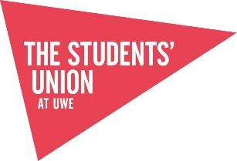

SU001- Negative Environmental Impacts 2024-2025

Criteria
Identify the organisation's most significant sustainability impacts and publish them.

Further Information
All students' unions and associations have issues where they could make improvements to reduce their negative sustainability impact and increase their positive impact, such as energy use, procurement, waste production etc.

Identifying specific impacts, and ranking them in terms of the relative size of the negative impact, can help organisations prioritise their sustainability actions.

If using an existing list of impacts from previous year's participation in Green Impact, the list should have been reviewed this year.

How will you be audited
Auditors will be looking for a well-documented assessment of at least the top five sustainability impacts of the union/association. The list should be ranked by magnitude of the negative impact. There is no right or wrong way to do this, but plenty of guidance is available online. There will be variation between unions/associations depending on what operations they have: commercial unions/associations may have different impacts to non-commercial; multi-site unions/associations may have different impacts to single site etc.

Evidence will revolve around the list of impacts. The list should be dated and in the public domain (such as on the website). Ideally, the impacts will be quantified (the amount of miles, the size of carbon emissions, the weight of waste to landfill etc.) and there will be reference to what you are doing to reduce them.

The Students’ Union has been reporting on our negative environmental impact for the last 6 years:
- Please find attached our negative impact report, also available to view through our Sustainability WebPage: https://www.thestudentsunion.co.uk/sustainability/sustainabilityactionplans/
- The report details a range of environmental impact and lists them in rank order, according to CO2e. We have chosen the impacts due to the monitoring and reporting systems The Students’ Union and UWE Bristol have in place.
- We detail the efforts taken presently to reduce these negative impacts and the plans moving forward.
- The University and The Students’ Union at UWE took the decision during 2018 to work towards inclusion of the student union into the scope of the university’s ISO14001 management system. Despite the two organisations being separate legal entities, they already collaborate on environment and sustainability at a variety of levels from provision of related building services and facilities through to sustainability governance and awareness campaigns. A review of SU-related environmental aspects and impacts took place during November 2018. This review is a requirement of the ISO14001 standard and will enable the university and the SU to better understand key environmental and sustainability risks and opportunities.
- Moving towards UWE’s 2030 target of a net carbon neutral campus, we will be understanding our impacts in all three scopes of mapping our carbon footprint.
- The Students Union have been working with UWE Estate Carbon and Supply Chain (Scope 3) Officer Tom Finn who has been advising and support regarding mapping, coding our procurement with further estimation on the carbon associated with in. This work is still in progress and explored to be applied to the organisation, particularly our commercial services who have a high procurement rate.
- In addition to this we have explored what it would require measuring our travel more accurately for both our student and staff activities.
For students we have looked to amend and develop our fuel/milage claim form so that we request the type of vehicle which would lead us to be able to apply a more accurate conversion rate. https://www.gov.uk/government/publications/greenhouse-gas-reporting-conversion-factors-2023
- For our staff travel we have looked at our current expenses system where fuel and milage claims are tracked can be edited to include the type of vehicle. Our Finance Manager has informed us that our current system (Staff Savvy) will not support this functionality. In the future when tendering a new financial HR system, we will look ensure this function is available.

Below is the methodology of the scoring: [extracted from our procedure’s manual]
Significance Scoring Methodology

The scoring criteria for assessing the significance of each aspect is outlined below:
 | 1 | 2 | 3 | 4
Direct or indirect control | Indirect / Influence | Direct control
Frequency of activity | Negligible usage/infrequent operation | Low usage/Normal operation | Moderate usage/Abnormal usage | High usage/ emergency conditions
Environmental effect | Insignificant | Minor | Moderate | Major
Stakeholder Interest | Limited | Moderate | High
Existing controls | Full control/no requirement for control | Moderate control | Limited control | No controls
Compliance Obligations | No relevant obligations | Compliant with obligations

The Students’ Union have started this work from scratch again with UWE Bristol, in light of our 2030 commitments to reach net carbon neutral across all 3 scopes. We have been working proactively with UWE Sustainability and UWE Energy Teams to look at an approach.
We met with all department heads to scope al their departmental activities and the decision they make. We mapped what data was already being captured and if it wasn’t why not and how it could moving forward.
The Students’ Union attended a webinar on carbon management (please find notes attached) and are using this framework to support our approach.
6 steps - CARBON
- Check – working with all departments and UWE to map our scopes of activity. Check was data we collect.
We have worked with UWE to improve our data set across waste, energy and water, with new meters and better deep dives into certain areas.
- Assess – we are now assessing common themes across the departmental mapping to pull out key areas we know we have a big impact, to either better record and assess this, so we can reduce and monitor, or to enable us to estimate our carbon footprint overall more successfully. These projects will then feed into our new 4 years strategic plan action planning cycle.
- Record – we have worked with our Finance Manager to create a new negative environmental impact dashboard and database. We can more effectively update these figures and monitor our progress year on year. We can add in new data sets as we being them on board and enable better reporting. Please find attached our new database showing our top 5 negative environmental impacts.
- Brainstorm – Bringing together 2 and 3, looking at the best gaps to fill and make the most impact. Working with student leaders and departments to go this effectively.
- Ordering – create the plan!
- Numbers

As part of our Assessment Phase, we believe a piece of work on staff travel, purchasing and supply chains are key focus areas for future years. Our student survey tells us that a main driver for students is single-use plastic, so this will be the third priority area for audit, reduction plan and monitoring.

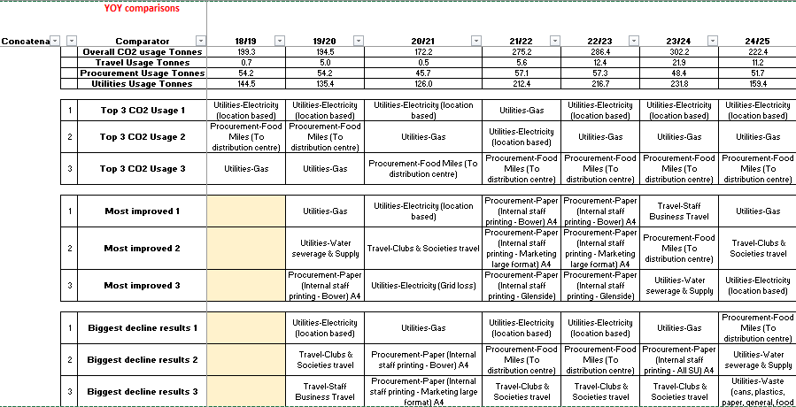

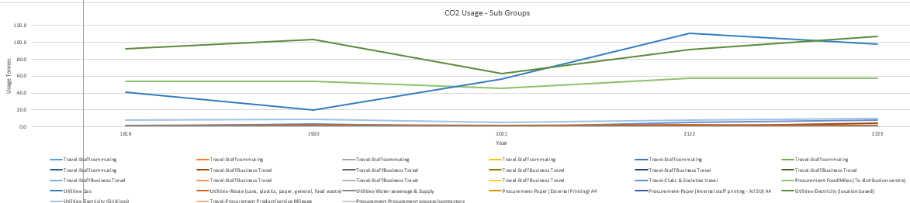

Appendix – Notes on negative environmental impact 2024-2025
Energy Data Information
- One key element to note this year is the data range. Due to the adjustment made by the deadline for submission for Green Impact 2024-2025 we have changed this year’s data range to 1st April 2024 – 31st January 2025. Next year 2025/2026 will be a full calendar year of 1st Feb – 31st January and this will be the same year on year.
Therefore this year’s data may look like a year on year improvements however it is reflective of 9 month of data instead for 12 months.
- Improved meters across SU venues so can have accurate reports and localised reporting.
- Resolved an issue with meter reporting in The Students’ Union means recording is now more accurate, this means past data is not reliable for comparisons.
- Have a stable data set for the future to support 2030 net carbon neutral goals
- UWE Bristol working with a specialist company to commission every single meter to know it is accurate.
- Energy consumption has increased due to increase in building use, better metering and more accurate reporting, and means previous stats inaccurate and not able to account for it.
- Splitting data of commercial and non-commercial to see how controls in the Union 1 building on student activity is holding the data steady. We are going to explore with UWE’s Energy Team.
- Our Community Manager, Buildings Manager and Commercial Services Director have been working with UWE Carbon Action Manager to look further into the SU utilises usage. Thus far it has included:
  - SU Staff having access to live utilities data software;
  - Meetings held to look at the scope of the project and to get some clarity moving forward;
  - SU Buildings Manager completed user feedback in relation to use of the buildings focusing on utilities;
  - Onsite walk through to understand the functions of each area and details (such as opening times, high/low usage) and being able to visually see the space with UWE;
  - From this a U Block Energy Survey has been complete and will be explored further by UWE and The SU.

Waste Data
The SU has 3 bin store locations, The Student Union, and Halley Nursery at Frenchay campus and The Student Union at Glenside campus.
We have had a shared bin store at Frenchay, since November 2021, with 3 other departments (Bristol Robotics Labs. Heath Tech Hub, CFPR Centre for Fine Print Research). However, the new bin store for W block is complete so we now only share the bin store with the Bristol Robotics Lab.
With the changes, the following split has been applied: 75% for General Waste, Paper & Card and Plastics & Cans and 100% for Glass and Food Waste.
We are well into our contract with Suez, who provide actual weights for all bin tips so we can now get a true reflection of what our recycling figures are. We operate under a pay by weight model and bins must be 50% full to be tipped. There is a small lift fee each time a bin is emptied so this rule will ensure we aren’t paying for barely filled bins to be tipped.
Food and glass are tipped weekly no matter how full they are to avoid them getting too heavy and avoid anything sitting in the bins for too long.
Here are a few key points from the 10-month period from April 1st 2024 to January 31st 2025.
- A total of 26,284kg were produced over all 3 locations with a C02e of 0.53 per tonne.
- The Student Union on Frenchay campus is the biggest producer of waste, having a total of 14,618kg. However, this bin store has by far the best waste segregation with a recycling rate of 89.12% and a very impressive 48.73% of the total waste coming from paper and cardboard.
- The Student Union have an overall recycling rate of 59.91%.

Printing Information
- We’ve maintained our ink & paper log for our large format printer to keep a track of how much ink & paper we’re using over the course of the year so that we can compare against years before.
- The only access feature we have on our Canon printers is a report on the all-time stats. We’ve added this to our monthly process to keep track of our main office printers so we can keep track of the print numbers so we will be able to provide a break down on A4/A3, black & white/Colour, 1 sided/2 sided prints.
- The number of physical printers remains the same as last year, we currently use 3 main all in one office printers, with 1 large format printer & 5 small form factor printers in the small offices across Frenchay & Glenside. We will look to reduce the number of small form factor printers next year to reduce our carbon footprint.

Digital Signage
- We recently completed an audit check to make sure all V-IT digital signage screens had auto turn on/off enabled. This is done as part of the installation process on all new screens to ensure we save energy. This is also adjusted to shorter auto on/off times during the Christmas & summer holidays. As for our Moxie digital signage PCs, the auto on/off is setup on the BIOS when the digital signage operating system is built. All digital signage operating system builds are built by UWE ITS.
- All digital signage screens across our three campuses are programmed to auto turn on at 7:59am & auto turn off at 23:00pm & the signage goes live at 8:00am every day of the week. This is to allow for the system to boot for a minute before the signage playlist goes live.
- The digital signage screens stay on for 15 hours a day & it consumes approximately 2.625 kWh of energy. If the screen were to stay on for 24 hours, it would consume approximately 4.2 kWh of energy. Having the screens on for 15 hours a day instead of 24, saves us 1.575 kWh of energy which is the equivalent of charging 126 iPhones.

Workstation Screens
- We recently completed an audit check on all of auto turn off compatible monitors across the organisation. New BENQ & HP monitors are configured to auto turn off after 10 minutes of inactivity. Older BENQ & HP monitors that don’t have the auto turn off feature have stickers on to remind staff to turn off the monitor once they’ve finished using them.
- All new BENQ & HP monitors are configured to auto turn off before they’re installed onto workstations across our three campuses.
- If our most common HP E24u G5 monitor stayed on for 24 hours, it would consume approximately 0.54 kWh of energy. Having the auto turn off feature enabled, the monitor would be used on an average of 8 hours per day, consuming approximately 0.18 kWh of energy. Saving 0.36 kWh of energy per day, which is the equivalent of charging 29 iPhones.

Marketing
- When entering a marketing request on our ticket system, each team is being reminded: ‘Before requesting printed material, please take into consideration the impact of the materials and decide if they are necessary for the campaign duration.’
  - Evidence:
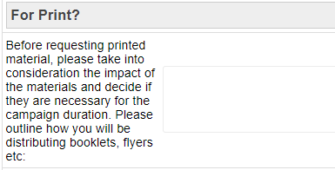
- The Marketing team ensures teams are aware of the variety of existing marketing channels outside of printed posters for every campaign.
- As often as possible, we design assets with no specific date so they can be reused.
  - Example: Elections banners.
  - Example: Freshers’ Fair wayfinding.
  - 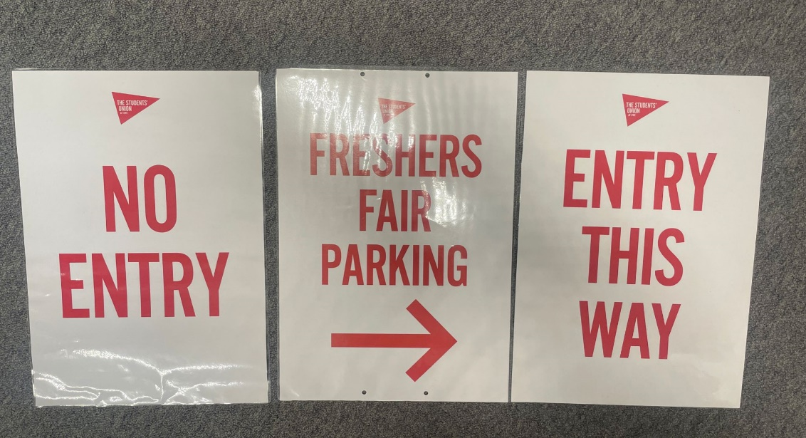

- We have been using off cuts from our large format printer for A3 and A4 printing.
  - During our Anti Sexual Violence Awareness Week, the team created a pop up stall in one zone to provide useful give always to students, which included branded mugs and bookmarks. To minimise waste, off cuts from the Large Format Printer were used to create campaign bookmarks to give away to students. Evidence:
  - 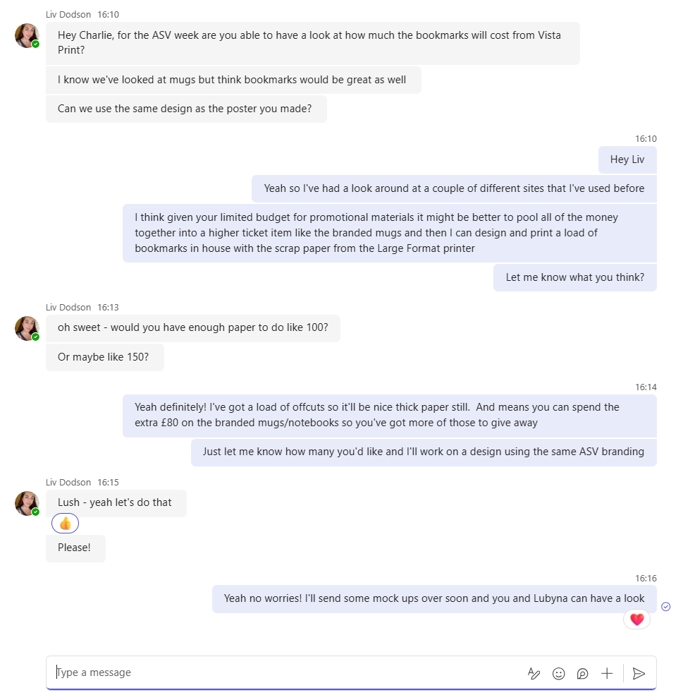

- The Media Pack we send to prospective commercials is entirely digital. We have created an online magazine which means that we reduce the amount of data we send to each commercial as we are not attaching a PDF to each email.
- We make sure our large poster frames across campus contain year-long campaign posters, in order to reduce having to print new posters on a regular basis. We also make sure our poster frames have locks ensuring the print work stays in the poster frame and we don’t have to replace it.
- We have installed a new large digital screen on the outside of our main Students’ Union building, replacing the need for large mesh banners throughout the year. We have restrictive viewing of this from 8:00 – 20:00 on weekdays only to save on energy usage.
- Alongside our own, we utilise UWE digital channels including social media, digital screens, computer pop ups, e-newsletters etc. We also utilise other digital screens which are managed by external companies. This helps us to minimise the use of printed promotions across campus.

Building Control Measures
The Students Union Buildings Manager continues to ensure that buildings are operated as efficiently as possible within the existing infrastructure. Below are examples of actions completed that has potential impact of reducing our gas and electrical output.
In October 2024 the energy saving signage was updated in our premises to reinvigorate the messaging in our areas.
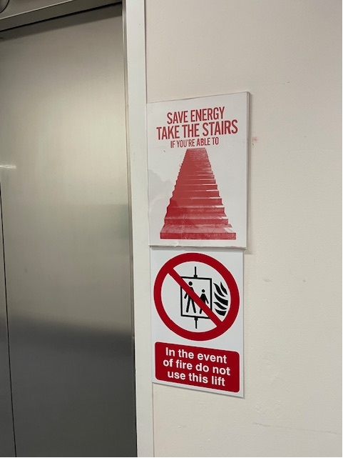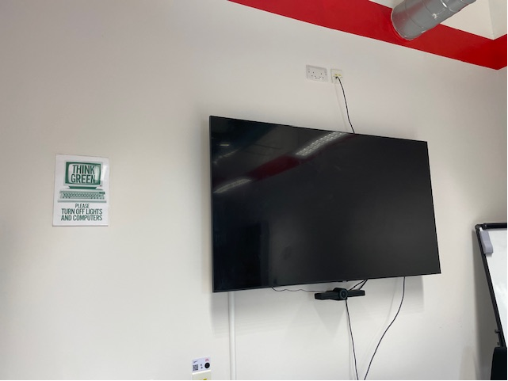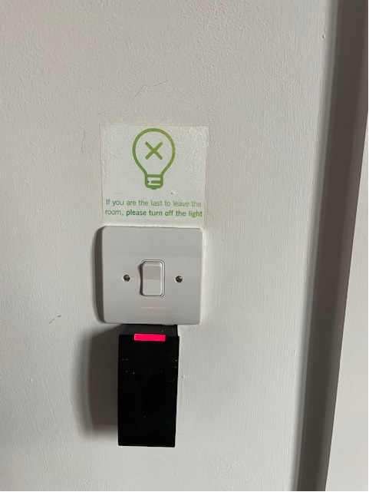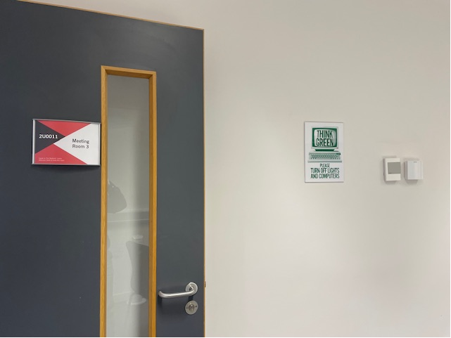

The Buildings Manager continues to support using our utilities effectively with such practices as staff awareness emails and liaising with UWE Estates for heating turn off over the Christmas 2024 period when our facilities are closed off, evidenced in the emails below.
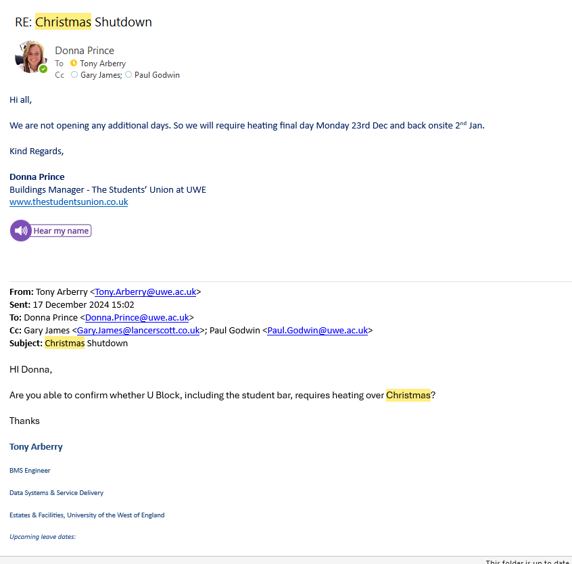

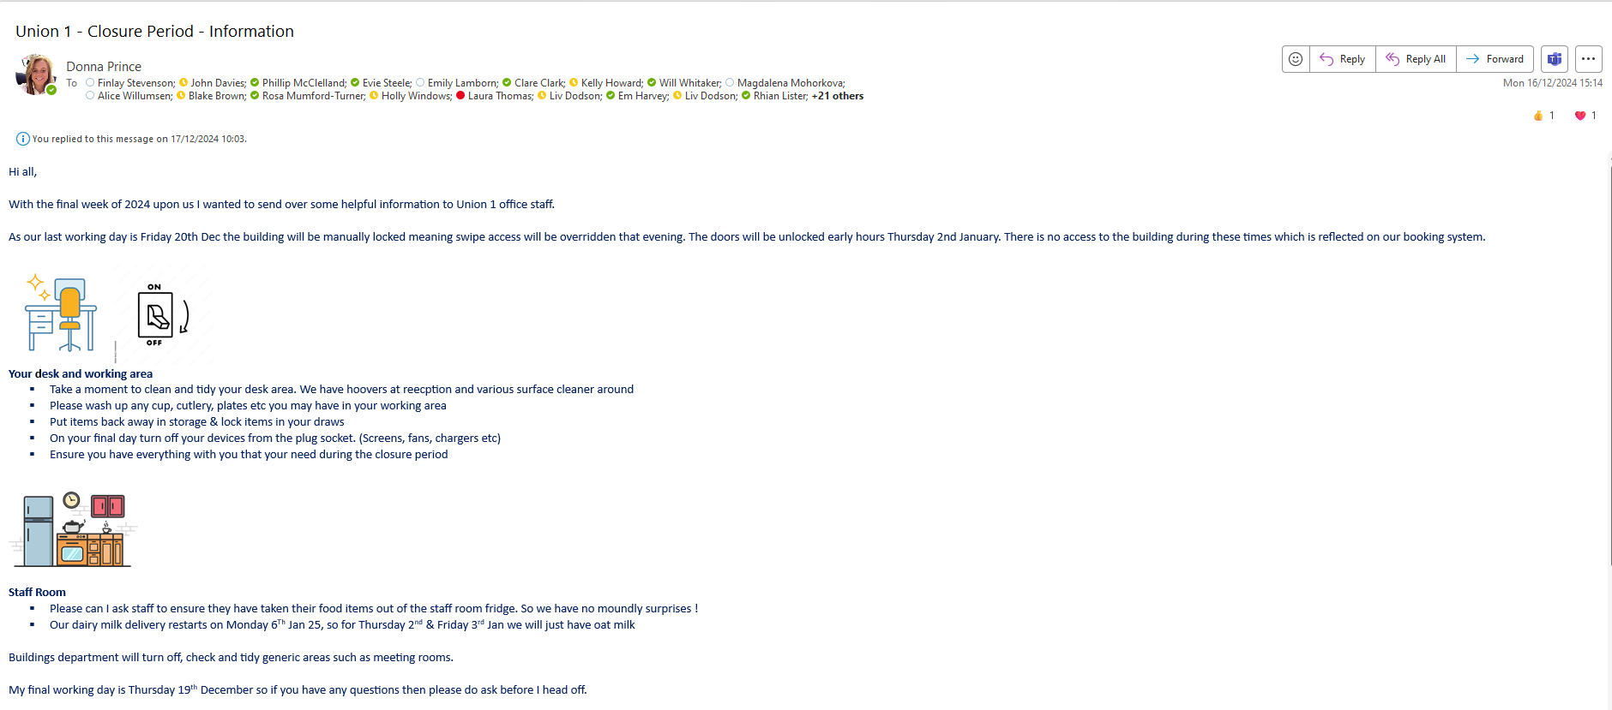

SU Halley Nursery – Heating System Improvements
Donna Prince (SU Buildings Manager) & Sarah Cox (SU Nursery Manager) have been working with UWE Estates Tony Arberry (BMS Engineer) in 2024-2025 for improvement works to the Halley Nursery which is ran by The Students at UWE. As buildings users we noted and raised issue with the existing heating systems such as fault thermostats meaning the building was wasting energy as the building management system (BMS) was not reading accurately. The control system was not common to the site wide BMS at UWE and support/spares were becoming difficult to source for repair and therefore, there was a need for action.
Across UWE Estate there is a UWE Carbon reduction initiative to reduce the number of gas boilers where possible and the Nursery also requested temporary cooling in the summer.
A survey concluded this should be replaced with ceiling mounted air conditioning units and electric HWS, providing more flexible control and setpoints that can be trimmed to suit each room's requirements. Including a cooling option also reduced the need to hire temporary summer cooling (costing approx. £3-4k per annum).
The original installation caused the boiler to cycle on/off before the heat had reached the building's extremes, making it inefficient. Removing the wet system also reduced the risk of leaks and scalding from high flow temperatures on exposed pipework. Most of the radiators were boxed in to prevent them from being touched and this also reduced their efficiency.
Since these improvements we have much more reliable, energy efficient and ability to set local temperatures and being in a nursery environment each room has different temperature needs.

Transition from S Drive to SharePoint / OneDrive
In the last 6 months we’ve migrated from a network access storage device located on campus SharePoint on Microsoft Teams & OneDrive. Migrating to Microsoft Teams enhances our digital footprint by streamlining communication and collaboration, improving brand visibility, leveraging cloud-based flexibility, and promoting security and compliance. It also demonstrates our commitment to using modern, efficient tools, which can lead to a stronger and more professional digital presence.

Commercial Services
In the early part of this academic year, the Commercial Services team signed up to the NUS Sustainable SU’s Charter, now comprising of 14 members.
The aim of the Charter is to unite Students’ Union’s in fostering sustainable practices aligned with an ambition to deliver choice, nutrition and affordable food service and retail solutions within a modelled Net Zero plan, promoting education and awareness, adopting sustainable practices, offering sustainable food and beverage options and measuring and reporting on progress.
The Charter is underpinned by 12 commitments, some of which have been completed or progressed already through our sustainability work over the last couple of years. These include promotion of vegetarian and vegan options, equal pricing for plant-based alternatives, reduction of single-use packaging, and supporting a transition to sustainable clothing supply.
We have recently launched our new menu in our Union 2 outlet, using the Klimato carbon labelling system to show the environmental impact of our main meals, giving students the opportunity to make informed choices regarding what they eat, based on a simple A-E rating.
We have also just had the report and data from the carbon footprint project we are working through with Energise. Before Christmas, we provided Energise with data relating to various elements including energy consumption, staff travel, purchasing and refrigerant gas use. We now have the information to identify areas to inform our strategy moving forward and look at how we can focus our efforts to reduce our carbon footprint.

