

SU001- Negative Environmental Impacts 2025-2026

Criteria
Identify the organisation's most significant sustainability impacts and publish them.

All students' unions and associations have issues where they could make improvements to reduce their negative sustainability impact and increase their positive impact, such as energy use, procurement, waste production etc. You can use our template if you're not sure where to start!

Identifying specific impacts, and ranking them in terms of the relative size of the negative impact, can help organisations prioritise their sustainability actions.

If using an existing list of impacts from previous year's participation in Green Impact, the list should have been reviewed this year.

The way we have scored actions has changed this year - each action below that you complete will add to the total number of points that you receive.

1 point if you have listed things you are doing for sustainability on your website.

2 points if you have a well-documented assessment that clearly identifies at least 4 impacts that your building and/or work has on nature & the climate. These impacts should be ranked by the magnitude of their impact.

2 points if you have quantified the impacts of these environmental impacts (e.g. miles travelled, amount of waste to landfill, carbon emissions produced)

2 points if you have documented action plans to mitigate these environmental impacts with timelines.

3 points if you have made progress towards mitigating these environmental impacts, your progress has been documented, and the impacts, along with action taken to mitigate them, have been published online and written in a way that is accessible to all students (in plain English).
Ideal evidence would include: links to your website where this information is available, and if it is not available online, copies of the documents to show your environmental impacts, action plans, and progress towards mitigation.

The Students’ Union has been reporting on our negative environmental impact for the last 8 years:
- Please find attached our negative impact report, also available to view through our Sustainability WebPage: Sustainability Action Plans
- The report details a range of environmental impact and lists them in rank order, according to CO2e. We have chosen the impacts due to the monitoring and reporting systems The Students’ Union and UWE Bristol have in place.
- We detail the efforts taken presently to reduce these negative impacts and the plans moving forward.
- The University and The Students’ Union at UWE took the decision during 2018 to work towards inclusion of the student union into the scope of the university’s ISO14001 management system. Despite the two organisations being separate legal entities, they already collaborate on environment and sustainability at a variety of levels from provision of related building services and facilities through to sustainability governance and awareness campaigns. A review of SU-related environmental aspects and impacts took place during November 2018. This review is a requirement of the ISO14001 standard and will enable the university and the SU to better understand key environmental and sustainability risks and opportunities.
- Moving towards UWE’s 2030 target of a net carbon neutral campus, we will be understanding our impacts in all three scopes of mapping our carbon footprint.
- The Students Union have been working with UWE Estate Carbon and Supply Chain (Scope 3) Officer Tom Finn who has been advising and support regarding mapping, coding our procurement with further estimation on the carbon associated with in. This work is still in progress and explored to be applied to the organisation, particularly our commercial services who have a high procurement rate.
- In addition to this we have explored what it would require measuring our travel more accurately for both our student and staff activities.
For students we have looked to amend and develop our fuel/milage claim form so that we request the type of vehicle which would lead us to be able to apply a more accurate conversion rate. https://www.gov.uk/government/publications/greenhouse-gas-reporting-conversion-factors-2023
- For our staff travel we have looked at our current expenses system where fuel and milage claims are tracked can be edited to include the type of vehicle. Our Finance Manager has informed us that our current system (Staff Savvy) will not support this functionality. In the future when tendering a new financial HR system, we will look ensure this function is available.

Below is the methodology of the scoring: [extracted from our procedure’s manual]
Significance Scoring Methodology

The scoring criteria for assessing the significance of each aspect is outlined below:
 | 1 | 2 | 3 | 4
Direct or indirect control | Indirect / Influence | Direct control
Frequency of activity | Negligible usage/infrequent operation | Low usage/Normal operation | Moderate usage/Abnormal usage | High usage/ emergency conditions
Environmental effect | Insignificant | Minor | Moderate | Major
Stakeholder Interest | Limited | Moderate | High
Existing controls | Full control/no requirement for control | Moderate control | Limited control | No controls
Compliance Obligations | No relevant obligations | Compliant with obligations

The Students’ Union have started this work from scratch again with UWE Bristol, in light of our 2030 commitments to reach net carbon neutral across all 3 scopes. We have been working proactively with UWE Sustainability and UWE Energy Teams to look at an approach.
We met with all department heads to scope al their departmental activities and the decision they make. We mapped what data was already being captured and if it wasn’t why not and how it could moving forward.
The Students’ Union attended a webinar on carbon management (please find notes attached) and are using this framework to support our approach.
6 steps - CARBON
- Check – working with all departments and UWE to map our scopes of activity. Check was data we collect.
We have worked with UWE to improve our data set across waste, energy and water, with new meters and better deep dives into certain areas.
- Assess – we are now assessing common themes across the departmental mapping to pull out key areas we know we have a big impact, to either better record and assess this, so we can reduce and monitor, or to enable us to estimate our carbon footprint overall more successfully. These projects will then feed into our new 4 years strategic plan action planning cycle.
- Record – we have worked with our Finance Manager to create a new negative environmental impact dashboard and database. We can more effectively update these figures and monitor our progress year on year. We can add in new data sets as we being them on board and enable better reporting. Please find attached our new database showing our top 5 negative environmental impacts.
- Brainstorm – Bringing together 2 and 3, looking at the best gaps to fill and make the most impact. Working with student leaders and departments to go this effectively.
- Ordering – create the plan!
- Numbers

As part of our Assessment Phase, we believe a piece of work on staff travel, purchasing and supply chains are key focus areas for future years. Our student survey tells us that a main driver for students is single-use plastic, so this will be the third priority area for audit, reduction plan and monitoring.

The Students Union at UWE – Negactive Impact Mapping – Year on Year

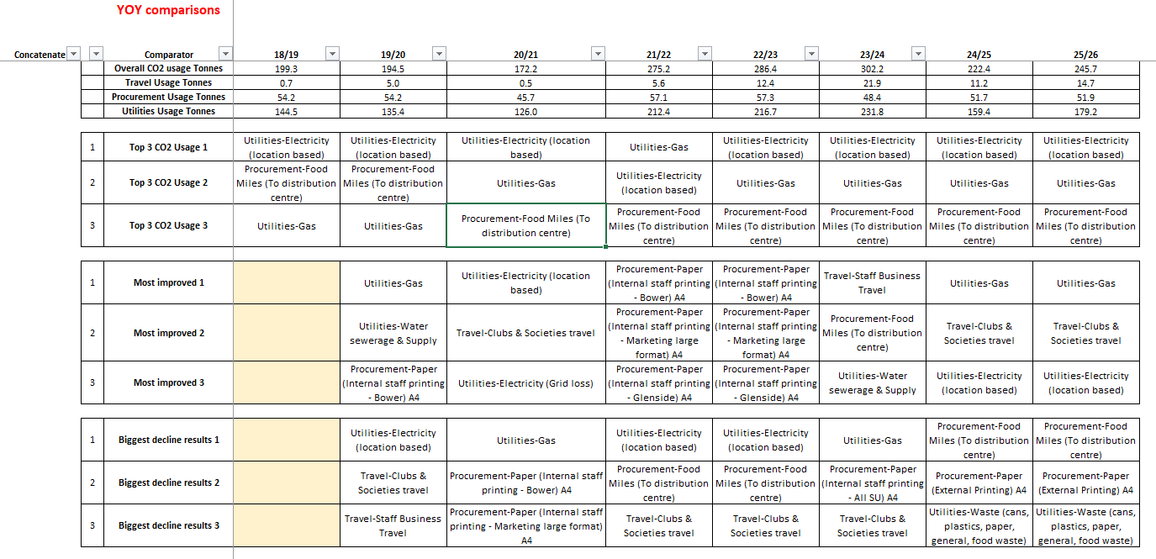

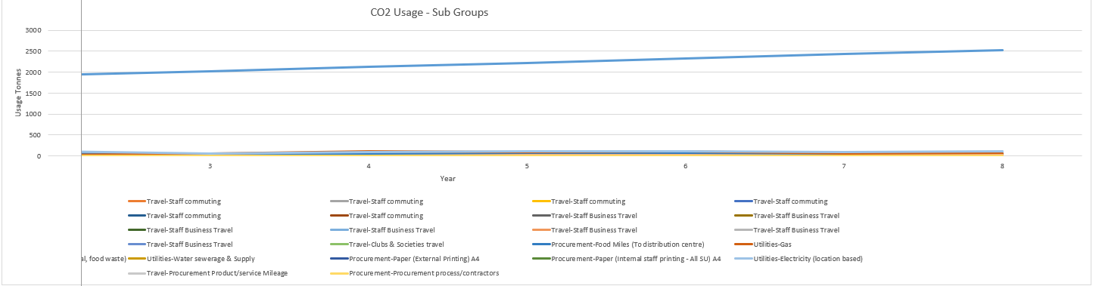

Appendix – Notes on negative environmental impact 2025-2026
Energy Data Information
- Improved meters across SU venues so can have accurate reports and localised reporting.
- Resolved an issue with meter reporting in The Students’ Union means recording is now more accurate, this means past data is not reliable for comparisons.
- Have a stable data set for the future to support 2030 net carbon neutral goals
- UWE Bristol working with a specialist company to commission every single meter to know it is accurate.
- Energy consumption has increased due to increase in building use, better metering and more accurate reporting, and means previous stats inaccurate and not able to account for it.
- Splitting data of commercial and non-commercial to see how controls in the Union 1 building on student activity is holding the data steady. We are going to explore with UWE’s Energy Team.
- Our Community Manager, Buildings Manager and Commercial Services Director have been working with UWE Carbon Action Manager to look further into the SU utilises usage. Thus far it has included:
  - SU Staff having access to live utilities data software;
  - Meetings held to look at the scope of the project and to get some clarity moving forward;
  - SU Buildings Manager completed user feedback in relation to use of the buildings focusing on utilities;
  - Onsite walk through to understand the functions of each area and details (such as opening times, high/low usage) and being able to visually see the space with UWE;
  - From this a U Block Energy Survey has been complete and will be explored further by UWE and the SU.
Halley Nursery is the most notable change this year with the gas supply having been fully removed and heating now provided solely by an air source heat pump that is electrically powered. This is significant in terms of our path to decarbonisation as we are moving away from fossil fuel (natural gas) supplies and making appropriate replacements to systems which are, or can in future, be powered primarily by zero carbon fuel sources. Even in this case where we are not yet fully zero, the impact of switching this fuel source which, due to a more efficient system as well as the reducing carbon intensity of electricity, has reduced the overall carbon footprint of the nursery even further this year. This change is reflected in overall emissions for the SU which show a good decrease from the last fully measured year (23/24).

It is notable that electricity use for the main students Union building (U Block) has gone up since 2023/24 and the only reason CO2 emissions haven’t increased is because of the reduced carbon intensity of electricity this year. This could be a focus for investigation in the coming year to try and establish where this increase has occurred and if there are any efficiencies or improvements that could be put in place to mitigate against this.

Waste Data
The SU has 3 bin store locations, The Student Union, and Halley Nursery at Frenchay campus and The Student Union at Glenside campus.
We have had a shared bin store at Frenchay, since November 2021, with 3 other departments (Bristol Robotics Labs. Heath Tech Hub, CFPR Centre for Fine Print Research). However, the new bin store for W block is complete so we now only share the bin store with the Bristol Robotics Lab.
With the changes, the following split has been applied: 75% for General Waste, Paper & Card and Plastics & Cans and 100% for Glass and Food Waste.
We are well into our contract with Suez, who provide actual weights for all bin tips so we can now get a true reflection of what our recycling figures are. We operate under a pay by weight model and bins must be 50% full to be tipped. There is a small lift fee each time a bin is emptied so this rule will ensure we aren’t paying for barely filled bins to be tipped.
Food and glass are tipped weekly no matter how full they are to avoid them getting too heavy and avoid anything sitting in the bins for too long. They are charged at a fixed rate so it doesn't matter how full or empty they are, we will be charged the same.
Here are a few key points from the 12-month period from February 1st, 2025, to January 31st, 2026.
- Frenchay campus has had an incredible increase in its recycling rate of 17.72%. The data shows that this is most likely due to better segregation of food waste as the overall weight of general waste is significantly down and food waste has increased.
- Glenside campus has shown similar improvement with there being almost a 10% increase in food waste. The overall weight of waste has increased by 2112kg but the overall cost to the SU has decreased as recyclable waste is collected at a lower rate.
- The Halley Nursery has also shown an improvement in their recycling rate of 14.45%. This is due to an increase in all the recyclable waste streams.

Printing Information
- We’ve maintained our ink & paper log for our large format printer to keep a track of how much ink & paper we’re using over the course of the year so that we can compare against years before.
- The only access feature we have on our Canon printers is a report on the all-time stats. We’ve added this to our monthly process to keep track of our main office printers so we can keep track of the print numbers so we will be able to provide a break down on A4/A3, black & white/Colour, 1 sided/2 sided prints.
- The number of physical printers remains the same as last year, we currently use 3 main all in one office printers, with 1 large format printer & 5 small form factor printers in the small offices across Frenchay & Glenside. We will look to reduce the number of small form factor printers next year to reduce our carbon footprint with 1 of our all-in-one office printers being decommissioned in April at Glenside.
Digital Signage
- We recently completed an audit check to make sure all V-IT digital signage screens had auto turn on/off enabled. This is done as part of the installation process on all new screens to ensure we save energy. This is also adjusted to shorter auto on/off times during the Christmas & summer holidays. As for our Moxie digital signage PCs, the auto on/off is setup on the BIOS when the digital signage operating system is built. All digital signage operating system builds are built by UWE ITS.
- All digital signage screens across our three campuses are programmed to auto turn on at 7:59am & auto turn off at 23:00pm & the signage goes live at 8:00am every day of the week. This is to allow for the system to boot for a minute before the signage playlist goes live.
- The digital signage screens stay on for 15 hours a day & it consumes approximately 2.625 kWh of energy. If the screen were to stay on for 24 hours, it would consume approximately 4.2 kWh of energy. Having the screens on for 15 hours a day instead of 24, saves us 1.575 kWh of energy which is the equivalent of charging 126 iPhones.

Workstation Screens
- We recently completed an audit check on all of auto turn off compatible monitors across the organisation. New BENQ & HP monitors are configured to auto turn off after 10 minutes of inactivity. Older BENQ & HP monitors that don’t have the auto turn off feature have stickers on to remind staff to turn off the monitor once they’ve finished using them.
- All new BENQ & HP monitors are configured to auto turn off before they’re installed onto workstations across our three campuses.
- If our most common HP E24u G5 monitor stayed on for 24 hours, it would consume approximately 0.54 kWh of energy. Having the auto turn off feature enabled, the monitor would be used on an average of 8 hours per day, consuming approximately 0.18 kWh of energy. Saving 0.36 kWh of energy per day, which is the equivalent of charging 29 iPhones.
Marketing
- When entering a marketing request on our ticket system, each team is being reminded: ‘Before requesting printed material, please take into consideration the impact of the materials and decide if they are necessary for the campaign duration.’
  - Evidence:
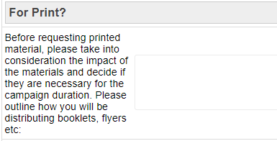
- The Marketing team ensures teams are aware of the variety of existing marketing channels outside of printed posters for every campaign.
- As often as possible, we design assets with no specific date so they can be reused.
  - Example: Elections banners.
  - Example: Freshers’ Fair wayfinding.
  - 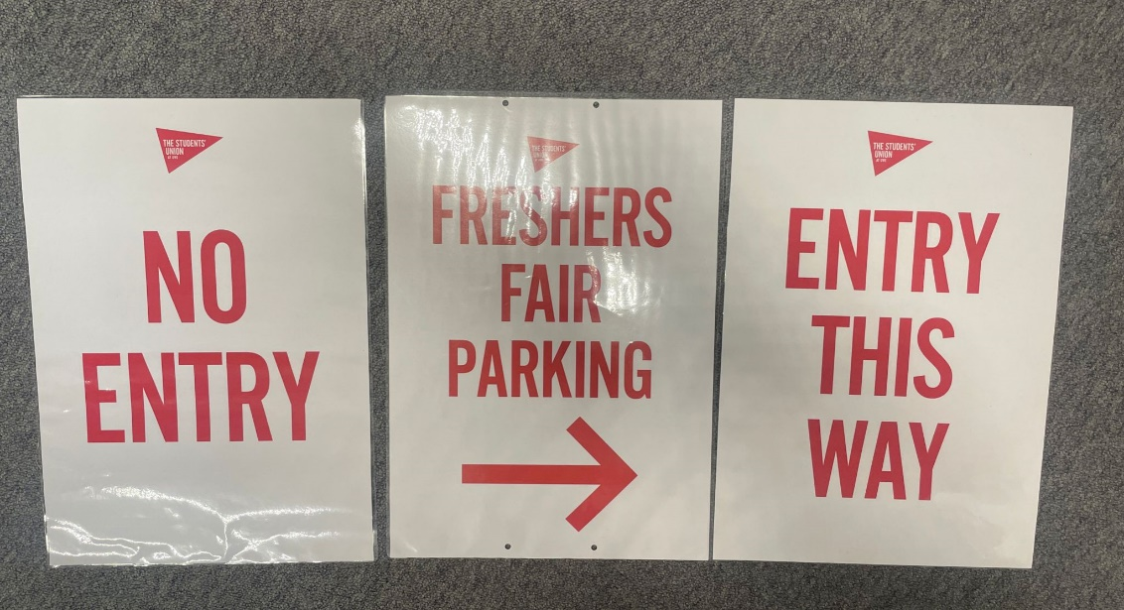

- We have been using off cuts from our large format printer for A3 and A4 printing.
  - Last year during our Anti Sexual Violence Awareness Week, the team created a pop up stall in one zone to provide useful give always to students, which included branded mugs and bookmarks. To minimise waste, off cuts from the Large Format Printer were used to create campaign bookmarks to give away to students. Evidence:
  - 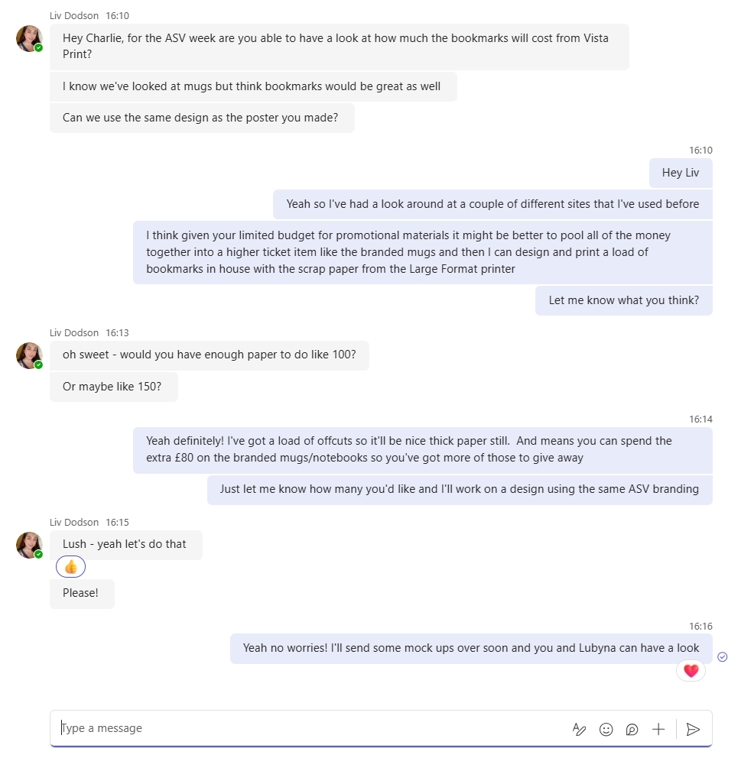
  - Since this, we have continued to use the offcut paper to refill our standard printer and as scrap paper for craft events during Liberation Campaign engagements.

- The Media Pack we send to prospective commercials is entirely digital. We have created an online magazine which means that we reduce the amount of data we send to each commercial as we are not attaching a PDF to each email.
- We make sure our large poster frames across campus contain year-long campaign posters, in order to reduce having to print new posters on a regular basis. We also make sure our poster frames have locks ensuring the print work stays in the poster frame and we don’t have to replace it.
- We have installed a large digital screen on the outside of our main Students’ Union building, replacing the need for large mesh banners throughout the year. We have restrictive viewing of this from 8:00 – 20:00 on weekdays only to save on energy usage.
- Alongside our own, we utilise UWE digital channels including social media, digital screens, computer pop ups, e-newsletters etc. We also utilise other digital screens which are managed by external companies. This helps us to minimise the use of printed promotions across campus.

Building Control Measures
The Students Union Buildings Manager continues to ensure that buildings are operated as efficiently as possible within the existing infrastructure. Below are examples of actions completed that has potential impact of reducing our gas and electrical output.
In November 2025 the energy saving signage was review in our premises to ensure that accurate signage was present.
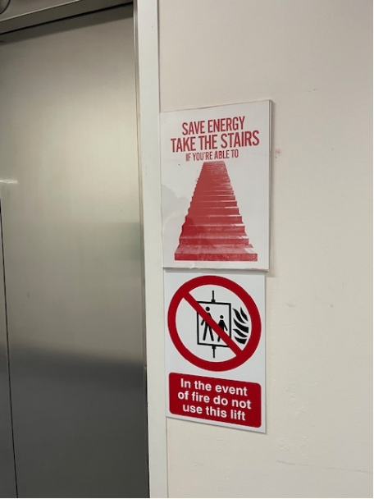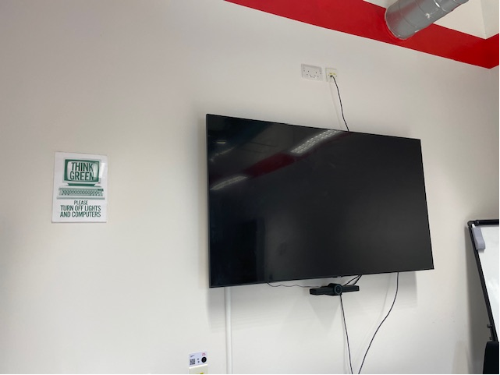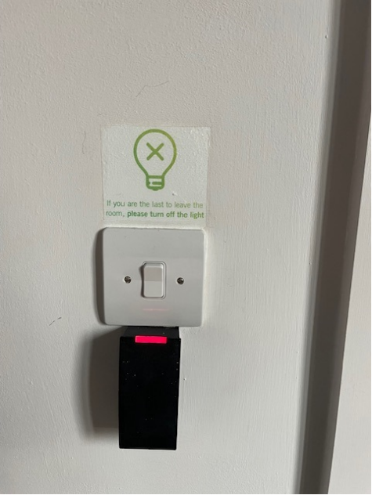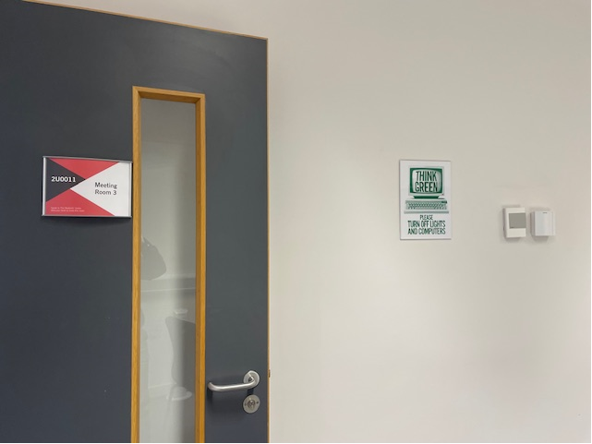

The Buildings Manager continues to support using our utilities effectively with such practices as staff awareness emails and liaising with UWE Estates for heating turn off over the Christmas 2025 period when our facilities are closed off, evidenced in the emails below.

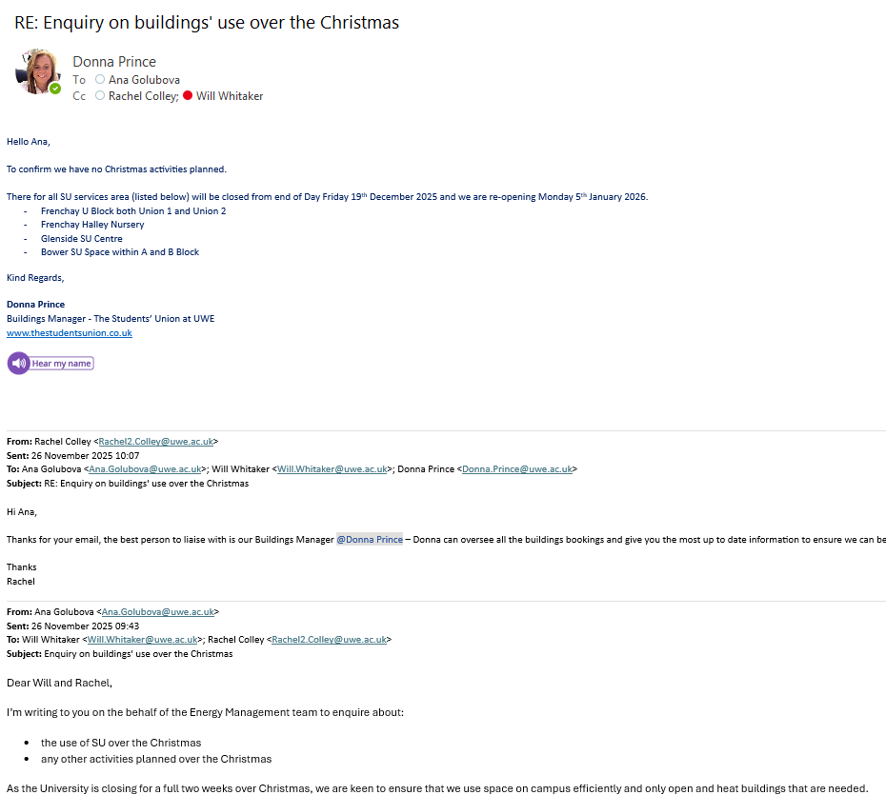

Transition from S Drive to SharePoint / OneDrive
In the last 12-18 months we’ve migrated from a network access storage device located on campus SharePoint on Microsoft Teams & OneDrive. Migrating to Microsoft Teams enhances our digital footprint by streamlining communication and collaboration, improving brand visibility, leveraging cloud-based flexibility, and promoting security and compliance. It also demonstrates our commitment to using modern, efficient tools, which can lead to a stronger and more professional digital presence.

Introduction of our Enviro Tech refurbished laptop scheme
We launched a new refurbished laptop scheme for students in partnership with a graduate start-up company to give students an opportunity to purchase a refurbished laptop at a low-price bracket. Since our launch in June of 2025, we have sold over 40 laptops to students. This is a great way of reusing decommissioned tech to lower the waste costs from a hardware & data perspective & also giving students the chance to purchase a laptop at a low cost, especially those that may have been unsuccessful in sourcing tech through other processes such as the UWE hardship fund. We will continue to wipe & refurbish all our decommissioned tech to help support students & reduce our wastage business wastage.

