SU001- Negative Environmental Impacts 2021-2022

Criteria
The union has identified its most significant negative [environmental impacts], and published them.

All students' unions have issues where they could make improvements to reduce their negative sustainability impacts and increase their positive impact, such as energy use, procurement, waste production etc.  Identifying specific impacts, and ranking them in terms of the relative size of the negative impact, can help organisations prioritise their sustainability actions.  If using an existing list of impacts from previous year's participation in Green Impact, the list should have been reviewed this year. | Auditors will be looking for a well-documented assessment of at least the top five environmental impacts of the union. The list should be ranked by magnitude of the negative impact. There is no right or wrong way to do this, but plenty of guidance is available online. There will be variation between unions depending on what operations they have: commercial unions may have different impacts to non-commercial; multi-site unions may have different impacts to single site unions, etc.  Evidence will revolve around the list of impacts. The list should be dated and in the public domain, and ideally on the union's sustainability webpage. Ideally the impacts will be quantified (the amount of miles, the size of carbon emissions, the weight of waste to landfill etc.) and there will be reference to what the union is doing to reduce them.

The Students’ Union has been reporting on our negative environmental impact for the last 5 years:
- Please find attached our negative impact report, also available to view through our Sustainability WebPage: https://www.thestudentsunion.co.uk/union/sustainability/action_plan/
- The report details a range of environmental impact and lists them in rank order, according to CO2e. We have chosen the impacts due to the monitoring and reporting systems The Students’ Union and UWE Bristol have in place.
- We detail the efforts taken presently to reduce these negative impacts and the plans moving forward.
- The University and The Student Union at UWE took the decision during 2018 to work towards inclusion of the student union into the scope of the university’s ISO14001 management system. Despite the two organisations being separate legal entities, they already collaborate on environment and sustainability at a variety of levels from provision of related building services and facilities through to sustainability governance and awareness campaigns. A review of SU-related environmental aspects and impacts took place during November 2018. This review is a requirement of the ISO14001 standard and will enable the university and the SU to better understand key environmental and sustainability risks and opportunities.
- Moving towards UWE’s 2030 target of a net carbon neutral campus, we will be understanding our impacts in all three scopes of mapping our carbon footprint.

Below is the methodology of the scoring: [extracted from our procedures manual]

Significance Scoring Methodology

The scoring criteria for assessing the significance of each aspect is outlined below:
 | 1 | 2 | 3 | 4
Direct or indirect control | Indirect / Influence | Direct control
Frequency of activity | Negligible usage/infrequent operation | Low usage/Normal operation | Moderate usage/Abnormal usage | High usage/ emergency conditions
Environmental effect | Insignificant | Minor | Moderate | Major
Stakeholder Interest | Limited | Moderate | High
Existing controls | Full control/no requirement for control | Moderate control | Limited control | No controls
Compliance Obligations | No relevant obligations | Compliant with obligations

2021-2022
The Students’ Union have started this work from scratch again with UWE Bristol, in light of our 2030 commitments to reach net carbon neutral across all 3 scopes.
We have been working proactively with UWE Sustainability and UWE Energy Teams to look at an approach. Working with Louise Finch, ISO 14001 Officer, we created new workshops for all Students’ Union departments, these ran in Autumn Term 2021 and the information reviewed Spring 2022.
We met with all department heads to scope al their departmental activities and the decision they make. We mapped what data was already being captured and if it wasn’t why not and how it could moving forward.
The Students’ Union attended a webinar on carbon management (please find notes attached) and are using this framework to support our approach.
6 steps - CARBON
- Check – working with all departments and UWE to map our scopes of activity. Check was data we collect.
We have worked with UWE to improve our data set across waste, energy and water, with new meters and better deep dives into certain areas.
- Assess – we are now assessing common themes across the departmental mapping to pull out key areas we know we have a big impact, to either better record and assess this, so we can reduce and monitor, or to enable us to estimate our carbon footprint overall more successfully. These projects will then feed into our new 4 years strategic plan action planning cycle.
- Record – we have worked with our Finance Manager to create a new negative environmental impact dashboard and database. We can more effectively update these figures and monitor our progress year on year. We can add in new data sets as we being them on board and enable better reporting. Please find attached our new database showing our top 5 negative environmental impacts.
- Brainstorm – Bringing together 2 and 3, looking at the best gaps to fill and make the most impact. Working with student leaders and departments to go this effectively.
- Ordering – create the plan!
- Numbers

As part of our Assessment Phase we believe a piece of work on staff travel, purchasing and supply chains are key focus areas for future years. Our student survey tells us that a main driver for students is single-use plastic, so this will be the third priority area for audit, reduction plan and monitoring.

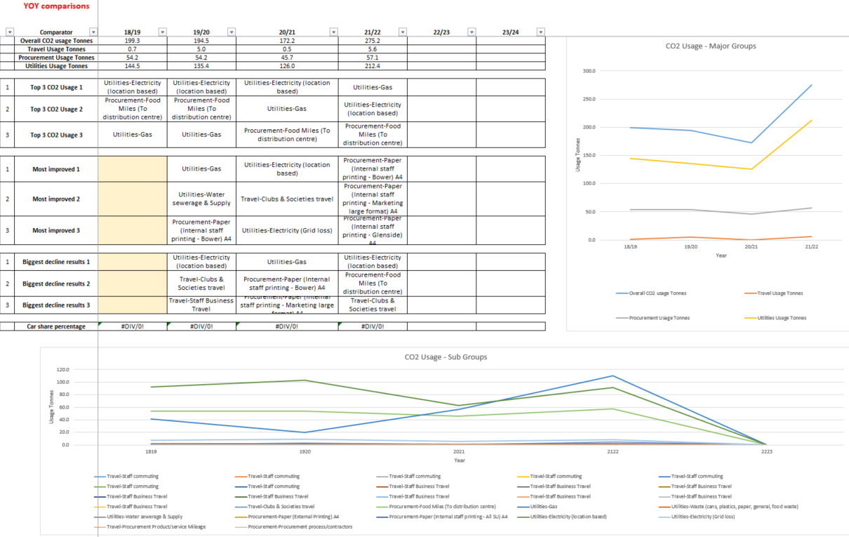

Appendix – Notes on negative environmental impact 2021-2022
Energy Data Information
- Improved meters across SU venues so can have accurate reports and localised reporting
- Resolved an issue with meter reporting in The Students’ Union means recording is now more accurate, this means past data is not reliable for comparisons
- Have a stable data set for the future to support 2030 net carbon neutral goals
- UWE Bristol working with a specialist company to commission every single meter to know it is accurate
- Changes in the grid changes the CO2 emissions – decrease in emissions for electricity from this year compared to precovid.
- Energy consumption has increased due to increase in building use, better metering and more accurate reporting, and means previous stats inaccurate and not able to account for it.
- Splitting data of commercial and non-commercial to see how controls in the Union 1 building on student activity is holding the data steady. We are going to explore with UWE’s Energy Team.
- In order to incorporate ghost energy data from sporadic working from home, we are going to find out how much home working and look at the impact of this compared to travel.
Electricity Emissions
- Electricity CO2e has reduced from 103 TCO2 to 89 TCO2e.
- This is a decrease of 14TCO2e, 13.6% decrease in CO2e (tonnes) emissions.
- This is the equivalent of charging 1,544,933 mobile phones or 2.5 homes’ electricity consumption for a year.
Water
- Reduced from 1,270 to 942 = 328m3, this is a 25.8% decrease in water usage (m3) compared to pre-COVID levels.
- This is a decrease of 0.83 TCO2e, 62.6% decreased in CO2e (tonnes) emissions. This is the equivalent of charging 91,592 mobile phones or consuming 1.7 barrels of oil.
- This saving is enough to provide water supply to OVER 1,577 full loads of laundry!
Waste Data
- Decrease in overall waste containers collected (from Frenchay, Glenside, Nursery), (463), this is a 11% decrease (compared to pre-covid)
- We saved £267.53 overall in waste collections (from Frenchay, Glenside, Nursery) compared to pre-covid.
- Increase in overall carbon emissions from waste: 2.17 (21/22) – 2.11 (19/20) total tonnes CO2e from waste.
- We have a shared bin store, since November 2021, with 3 other departments (Bristol Robotics Labs. Heath Tech Hub, CFPR Centre for Fine Print Research). We have not treated the data to reflect that not all the waste is from The SU. Moving forward, we might add the following: 50% for General Waste, Paper & Card and Plastics & Cans and 80% for Glass and Food Waste.
Please note all Glass and Food Waste weights are estimates due to the vehicles collecting not able to weigh, so estimated instead (as are sporadic weights for the other material types) assumed weights were actual weight not available as follows:
- General Waste – 40kg
- Paper & Card – 30kg
- Plastics & Cans – 30kg
- Glass – 35 kg
- Food – 40kg
Important to note that collections at Frenchay were significantly reduced and entirely suspended at Glenside for several months during 2020.
Nursery plastics and cans is not recorded as is not collected by the contractors, but it is collected into the central stores as the collection is sporadic and small amounts.
Also important to acknowledge is that carbon calculations for waste only really take into account transportation to the facility so there is actually no difference between energy recovery (general waste) and recycling reflected into the CO2e conversion. Whilst it isn’t reflected in the carbon emissions, there are other environmental reasons why we would promote recycling over general waste.
18/19 data is from a different contractor and therefore not a straight comparison to later years.
Printing Information
The Students’ Union Staff Printer Totals
- 2017/18 - 118,813 sheets of paper
- 2018/19 – 98,624 sheets of paper
- 2019/20 – 90,856 sheets of paper
- 2020/21 – 344 sheets of paper
- 2021/22 – 55,376 sheets of A4 paper and started tracking Nursery (14,567) = (69,943)
- We consumed 0.002637946512 TCO2e carbon emissions this year through internal printing (excluding nursery)
- We consumed 0.003331874691 TCO2e carbon emissions through internal printing, including nursery.

Not including new nursery stats:
- This year, we have saved 35,480 A4 pages, compared to pre-covid levels, this is a 39.1% decrease
- We saved 0.00169016076 TCO2 carbon emissions from reducing internal printing sources this academic year
- Reducing internal printing this academic year translates to 4.25 trees saved or 92.6 kg CO₂e, this could charge 11,264 mobile phones!
- This equates to 71 reams of A4 paper saved
- This saved The SU £276.90

Including Nursery stats:
- This year, we have saved 20,913 A4 pages, compared to pre-covid, including new nursery figure, this is a 23% decrease
- Reducing internal printing this academic year translates to 2.5 trees saved, 54.8kg CO2
- This equates to 42 reams of paper saved
- This saved The SU £163.80
Source - A ream of A4 paper from our provider, £3.490 for 500 pages.
Paper weight source
1 sheet a4 paper = 0.0044kg
Source for paper co2 data
1.1 tons co2e are produced for every ton (1016kg) paper produced
Carbon emissions from 1 piece a4 paper TCO2e | 4.76378E-06 |  | 0.000000047637
(Carbon emissions from 1 piece a3 paper TCO2e | 9.52756E-06

  - Data based on that a tree contains 16.67 reams of A4 sized paper (conservatree)
  - Data based on that a tree stores 21.75kg CO₂

Marketing Steps:
- When entering a marketing request on our ticket system, each team is being reminded: ‘Before requesting printed material, please take into consideration the impact of the materials and decide if they are necessary for the campaign duration.’
- Marketing team ensures teams are aware of the variety of existing marketing channels outside of printed posters for every campaign
- As often as possible, we design assets with no specific date so they can be reused.
- We send off cuts from our large formats to the nursery. For every A2 poster printed for example, the nursery receives a blank A3 for crafts.
- The Media Pack we send to prospective commercials is entirely digital. This year we have created an online magazine which means that we reduce the amount of data we send to each commercial as we are not attaching a PDF to each email.
- We make sure our large poster frames across campus contain year-long campaign posters, in order to reduce having to print new posters on a regular basis.

Travel
https://calculator.carbonfootprint.com/calculator.aspx?tab=6
https://www.goclimate.com/travel-calculator
1000 miles of bus travel = 40kg CO2e.

