SUSTAINABILITY EXECUTIVE REPORT
July 2024



GREEN IMPACT ACCREDITATION
We have completed our pre-audit for our annual Green Impact Students’ Unions (GISU) accreditation and we are awaiting the result of the submission. Thank you again to all those who contributed to GISU 2024, our partnership with the University is crucial in our reaccreditation. The result will be shared with key stakeholders in due course.

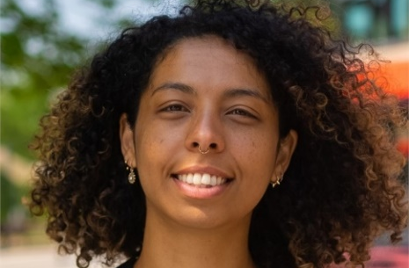
SUSTAINABILITY OFFICER
Chela is still working hard campaigning to save the below area (outlined in red) for rewilding. The 9.5-hectare site is on Frenchay campus and is currently set aside for development. The “rewilding” site would be accessible to students for wellbeing, research, and wildlife.
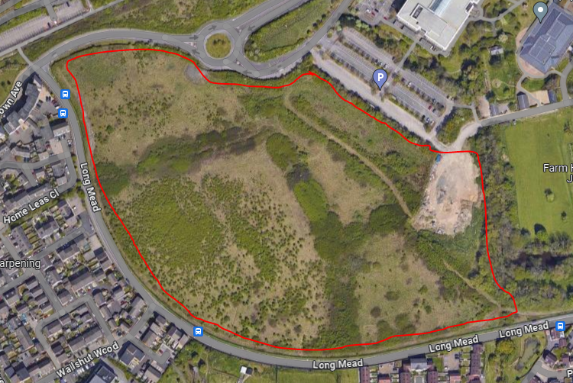
To aid her campaign, she used our Student Ideas platform to garner support. Her submitted idea can be seen here: https://www.thestudentsunion.co.uk/representation/student-ideas/527/. Her student idea received 4 stars and has now passed through the Student Council; it is now going to the next meeting of the Board of Trustees to be discussed.
She is currently in the process of writing a proposal to UWE and is in conversation with members of the sustainability executive board regarding developing this. To support her proposal, surveyed students and staff to gather their opinions on the rewilding idea. Her hard work has been well rewarded with 402 Students and 107 Staff filling out her surveys.
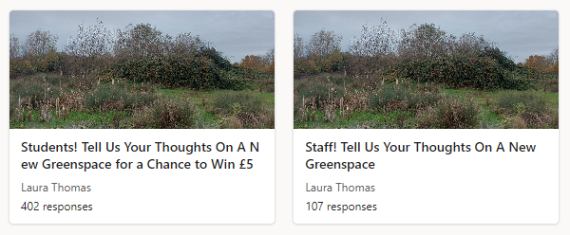

Chela has now analysed her data and written a blog to guide people through her results. The blog can be viewed here: https://www.thestudentsunion.co.uk/news/article/15570/Student-and-Staff-Opinions-on-a-Campus-Rewilding-Space/

3C’s: CLIMATE CONVERSATIONS AND CAKE
Our Sustainability Officer and Student Sustainability Engagement Coordinator have been working with Dr Sara Williams and Vicki Harris (and numerous UWE Bristol colleagues) to run Climate Conversation and Cake. This academic year, we have run 6 sessions and due to the success of the initiative have secured funding for Climate Conversation and Cake to run in the 2024/25 academic year.

WELCOME 2024
The Students’ Union have a variety of sustainability-themed events lined up for Welcome 2024. We will be running some of our successful events from last year such as a charity shop crawl, our community garden sessions and our bulb planting sessions. We are also adding some new events. A PhD student, Jelena, will be running an environmental film event where she will be facilitating discussion after the film. Additionally, The Sustainability Committee will hopefully host a BBQ in the Frenchay and Glenside Community Gardens, where they will be showing the fairy lights they have added to make the areas feel safer - which they hope will encourage the use of the gardens.

SUSTAINABILITY INDUCTION VIDEO
Our Student Sustainability Engagement Coordinator has been working with Vicki Harris to create this year's Sustainability Induction Video. We have booked a filming date with our videographer and hope to have the video ready for Starting Blocks in August.
The Students’ Union’s Student Representation Team will be co-ordinating the Students’ Union Inductions this academic year. Please email studentreps@uwe.ac.uk if Programmes are interested in a session, a MS Form will be created soon to manage bookings.
SOS-UK SUSTAINABILITY CONFERENCE
The President and our Student Sustainability Engagement Coordinator had the pleasure of attending the SOS-UK Student Sustainability Summit on the 29th of May. It was a great opportunity to learn about the fantastic sustainability initiatives that Students' Unions are implementing across the country and brainstorm ideas together. Our Student Sustainability Engagement Coordinator was also able to share the success of the 2022/23 Sustainability Committee's campaign on sustainable food as part of one of the workshops.
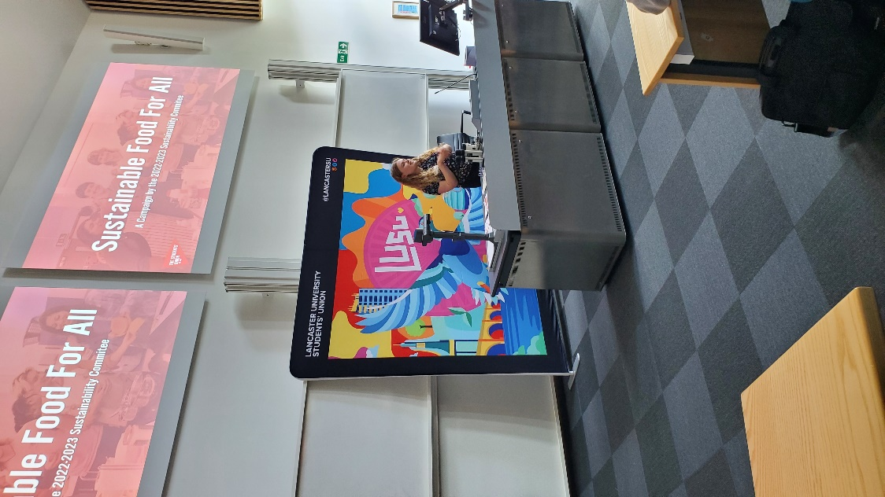
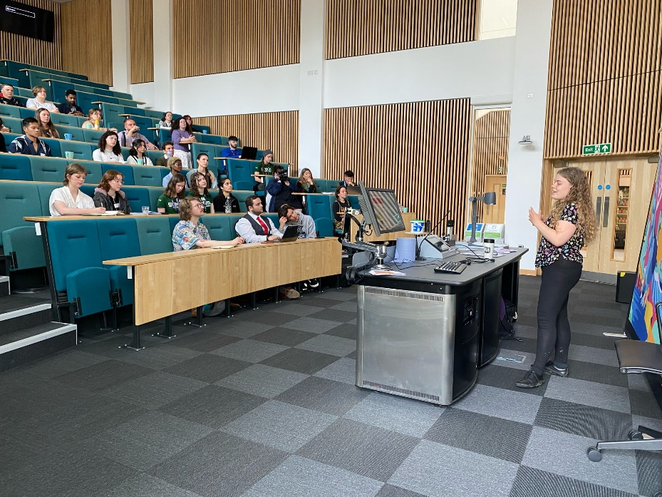
STUDENT EXPERIENCE AWARD HIGHLIGHTS
The Student Experience Awards (SEAs) are the Students’ Union’s equivalent of student-led teaching awards. This year, we have combined the Student Experience Awards with the Welfare Awards as we feel that welfare is an important part of the student experience. We recognised students and staff who have gone above and beyond in academics, community involvement, well-being, and more.
The event was organised by our VP Community and Welfare, Fayaz Kareem, alongside VP Education, Sabiha Khan. The awards took place in M Shed on Thursday 30 May. Fayaz expressed his thoughts on the event: "Hosting the Student Experience Awards was a true delight. It was a wonderful opportunity to recognise and celebrate the outstanding achievements of our students and staff at UWE over the past year." We were honoured to have special guests in attendance, including Vice-Chancellor Sir Steve West, who presented the Vice-Chancellor’s Award and delivered an inspiring speech.
Here are the award winners that were recognised for their work on Sustainability at UWE.
Student Environmental Champion Award: Chela Rossi
Chela serves as the Sustainability Officer for The Students’ Union, having previously been an engaged member of the Sustainability Committee. Her unwavering dedication is evident in her efforts to preserve green spaces across campus and advocate for eco-friendly alternatives at UWE Bristol.
Teaching for Sustainable Development Award: Martin Lewis
Martin passionately supports the inclusion of sustainability in the undergraduate nursing curriculum. Thanks to his efforts, UWE Bristol stands alone among nursing programs in England, offering a credited module dedicated to sustainability for undergraduate nurses.

