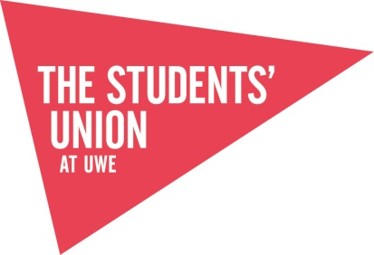

The Students’ Union at UWE – External Speaker Agreement

The Students’ Union is committed to providing a forum that facilitates Freedom of Speech while providing a safe space for our students and the public. We support events that contribute to extra-curricular development of students while requesting that all speakers and attendees are respectful of the beliefs and opinions of others as well as the laws that protect individuals and groups from intimidation, discrimination and harassment. By attending a Students’ Union event you are agreeing to uphold our policies and procedures regarding Freedom of Speech. Any breech of the Students’ Union policies and procedures may result in a Students’ Union disciplinary or further action being taken.

The above is intended to be displayed at any meetings/event which is hosting an external speaker. This should also be included in any emails and social media pages which are sent out/used to promote your events to students.

For more information, please see The Students’ Union at UWE’s policies:
- External Speakers Policy
- Safe Spaces Policy
- Zero Tolerance Policy Statement
- UWE’s Freedom of Speech Policy

